
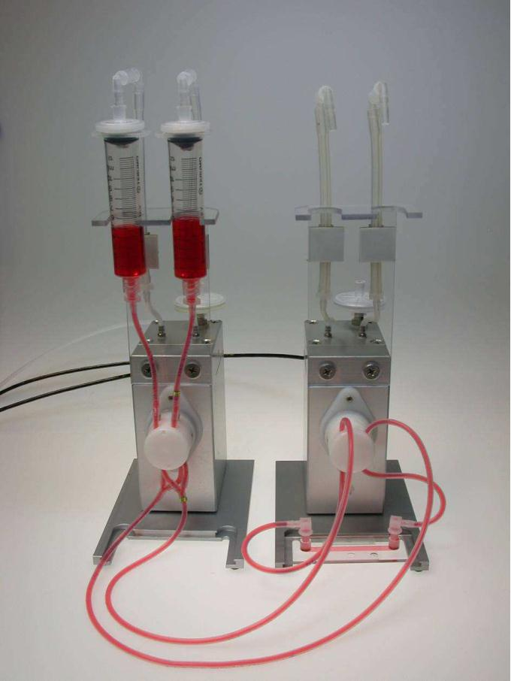
Instruction Manual for Pulsatile Flow
Version 1.5.0



1 Working principle and installation
As described in the general instruction manual the ibidi Pump and the ibidi Fluidic Unit are
designed to work together to create a flow – unidirectional, oscillating, or pulsating – of
medium within the channel of the ibidi slides. In order to create a pulsatile flow you need
one pump and two Fluidic Units. The first Fluidic Unit will create a unidirectional flow which
the second Fluidic Unit will periodically interrupt to create pulsation.
Please follow these steps to set up a pulsatile flow experiment:
1. Connect the pump to your computer and the two Fluidic Units to the pump. Plug for
example the first Fluidic Unit to ‘Port 1’ of the pump and the second to ‘Port 2’.
2. Connect the air pressure tubing only to the first Fluidic Unit.
3. Mount the Perfusion Set on the first Fluidic Unit.
•
This experiment works best with long Perfusion Sets like ‘yellow/green’,
‘white’, and ‘black’.
4. Using the pump and the first Fluidic Unit set up a continuous and unidirectional flow
with the desired flow rate and the resulting shear stress with the help of the
PumpControl software.
5. Route the tubing of the Perfusion Set which is coming out of the first Fluidic Unit
through the pinch valve of the second Fluidic Unit. Make sure that you use either the
two front or the two rear openings of the pinch valve for that. Do not intermix front
and rear openings. Compare your set-up with Figure 1.
6. Run the second Fluidic Unit in the PumpControl software as an ‘oscillating’ Unit. This
way you can select the switching time in the range of 0.2s – 5s which results in
pulsation periods of 0.4s – 10s. This in turn corresponds to frequencies of 2.5Hz –
0.1Hz. Set settings are shown in Figure 2.
ibidi instruction manual – pulsatile flow
© ibidi GmbH 2012, version 1.5.0, revision 0, 2012-04-19, Dr. Miro Kroutvar
1

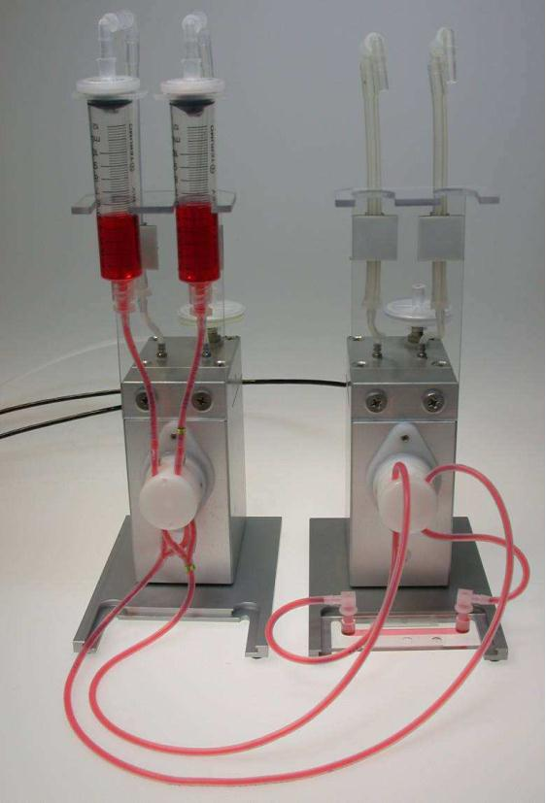

Figure 1 Set-up for pulsatile flow. Continuous flow in the Perfusion Set
coming out of Fluidic Unit 1 is periodically pinched off by Fluidic Unit 2.
ibidi instruction manual – pulsatile flow
ibidi GmbH 2012, version 1.5.0, revision 0, 2012-04-19, Dr. Miro Kroutvar
2

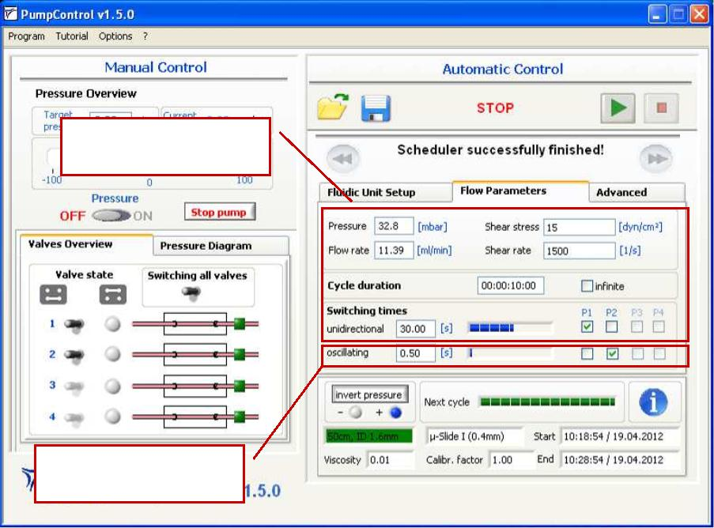
Fluidic Unit 1 creates a
continuous flow
Fluidic Unit 2 creates
pulsation (here: 1.0Hz)
Figure 2 Settings for PumpControl
ibidi instruction manual – pulsatile flow
© ibidi GmbH 2012, version 1.5.0, revision 0, 2012-04-19, Dr. Miro Kroutvar
3

