
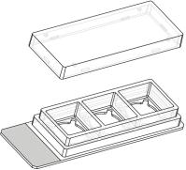
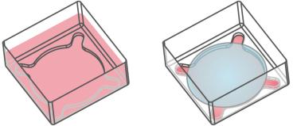
Instructions
3WellChamber,removable
The3WellChamber,removableisaremovablesiliconechamber,mountedonaglassslide,for
cellcultureandimmunoﬂuorescencestainings.Itallowstheuseofstandardcultivation,staining
andmountingtechniqueswithcoverslipsealing.
Aftermountingtheglassslidewithacoverslip,itisreadyfortheusewithuprightandinverted
microscopes,aswellasforlongtermstorage.Suitable24mm×60mmcoverslipsareprovidedby
ibidi(10811).
Thespecialgeometryofthe3WellChamber,removableprovidesastructureinsideeachwell,formingaroundinnerwell.
Theoptionofplacingaroundcoverslip(ibidi, 10815)intothewellallowstheusertoﬁlltheinnerwellexclusively, by
minimizingthevolumeandeliminatingthemeniscus.
Material
DimensionsoftheSingleWells
Dimensionofwells(w×l×h)
Volumeperwell
16.5×16.5×8mm
1100µl
The 3 Well Chamber, removable is comprised of a self–
adhesive silicone gasket mounted on a standard mi-
croscopyglassslide.Thegasketismanufacturedfrombio-
compatiblesiliconematerial. Althoughbothmaterialsare
autoclavableandcompatiblewithalcohols,wedonotrec-
ommendreusingthem. Theglassbottomexhibitsground
edgesandtwinfrostedends.
Reducedvolumeperwell
Growthareaperwell
Coatingareaperwell
Diameterofinnerwell
Heightoftheinnerwell
150µl
1.66cm2
3.37cm2
13.5mm
0.75mm
Geometry
ShippingandStorage
The3WellChamber,removableprovidesastandardslide
formataccordingtoISO8037/1.
The µ–Slides, µ–Dishes and µ–Plates are sterilized and
weldedinagas-permeablepackaging.Theshelflifeunder
proper storage conditions (in a dry place, no direct sun-
light)islistedinthefollowingtable.
GeneralDimensions
Numberofwells
3
Conditions
Bottomsize(w×l×h)
Twinfrostedends
Totalheightwithlid
26×76×1mm
13mm
Shippingconditions
Storageconditions
Ambient
11mm
RT(15-25°C)
Thesinglewellsofthe3WellChamber,removableconsist
oftheouterrectangularwellwithaninletformingaround
innerwell. Whenplacingacoverslipwith15mmdiame-
terontotheinlet, aseparatechamberislockedup. This
assuresahomogeneousdistributionofcellsorsubstances
andminimizestheliquidvolume. Theseparatechamber
canbeaccessedviafourinletsintheedges.
ShelfLifeofDifferentSurfaces
ibiTreat,GlassBottom,ESS
36months
18months
Collagen,Poly-L-Lysine
SurfaceandCoating
The 3 Well Chamber, removable is mounted on an un-
coatedglassslidewithtwinfrostedends. Washingsteps
(e.g. withPBS)beforecellseedingcanremoveglassdust
whichisadvantageousfordirectcellgrowthonthesur-
face.
Protein coatings increase direct cell growth of adherent
cells.Speciﬁccoatingsonglassarepossiblefollowingthis
protocol:
Left:Singlewellﬁlledwith1.1mlmedium.Right:Volume
reductionbyuseofthecoverslip(150µlmedium).
3WellChamber,removable
Page1
Version1.0(2016-02-02)


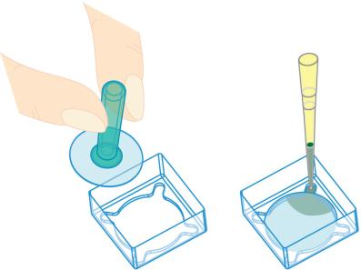
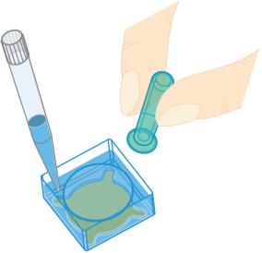
Instructions
3WellChamber,removable
• Prepareyourcoatingsolutionaccordingtotheman-
ufacturer’sspeciﬁcationsorreference. Prepareyour
slide. Adjusttheconcentrationtoacoatingareaof
3.37cm2andacoatingvolumeof1100µlperwell.
• GrabthecoverslipwiththePick-UpToolandplace
itontothewellinlet. ThePick-UpToolworkslikea
Pasteurpipette.
• Injectavolumeof150µlintooneoftheedges,that
arekeptopen.
• Apply1100µlintoeachwell.Makesurethattheen-
tirebottomiscoveredwithliquidbyslightlytilting
orshakingtheslide.Putonthelidandleavetheslide
atroomtemperatureforatleast30minutes.
• Aspirate the solution and wash with the recom-
mendedproteindilutionbuffer. Optionally, letdry
atroomtemperature. Attention, somecoatingpro-
teinsmightdegeneratewhendrying!
SeedingCells
• Trypsinizeandcountcellsasusual. Dilutethecell
suspensiontothedesiredconcentration.Depending
onyourcelltype,applicationofa2-6×104cells/ml
suspensionshouldresultinaconﬂuentlayerwithin
2–3days.
Removethecoverslipasfollows:
• Add950µlinonecornernexttothecoverslip.
• GrabtheﬂoatingcoverslipwiththePick-UpToolor
tweezersandremoveitfromthewell.
• Apply1100µlcellsuspensionintoeachwellofthe
slide.Avoidshakingasthiswillresultininhomoge-
neousdistributionofthecells.
• Cover the slide with the supplied lid. Incubate at
37°Cand5%CO2asusual.
Undemanding cells can be left in their seeding medium
foruptothreedaysandgrowtoconﬂuencethere. How-
ever, best results might be achieved when the medium
is changed every 1–2 days. Carefully aspirate the old
mediumandreplaceitby1100µlfreshmediumperwell.
Note:
SolventsforFixation,StainingandOtherPur-
poses
For a more homogeneous cell distribution use the
15mm coverslips (ibidi, 10815). Autoclave the cov-
erslipspriortouse. Pleasefollowtheprotocolbelow.
Use150µlofcellsuspensionwithaconcentrationof
1.7-3.8×105cells/ml.
3 Well Chamber, removable is compatible to methanol,
acetone,acids,alkalis,PFA,DMSO,siliconeoil,andmin-
eraloilforcellculture.
ImmunoﬂuorescenceMicroscopy
HandlingoftheRoundCoverslip
Aftercultivation,thecellscanbeﬁxedandstainedintwo
differentways.
Forﬁllingthechamberbyuseoftheroundcoverslip,fol-
lowthisprotocol.OneCoverslipPick-UpToolisdelivered
witheveryunitof15mmcoverslips(ibidi,10815):
Singlewelltechnique:
Allstepsarecarriedoutinthesinglewellsbeforeremov-
ing the silicone gasket. Using the 15mm coverslips will
reducethevolumeofthestainingsolutionto150µl.
• Beforeapplyingthecoverslip,thewellmustbeemp-
tied.
3WellChamber,removable
Page2
Version1.0(2016-02-02)

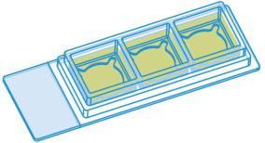
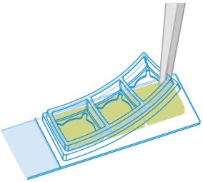

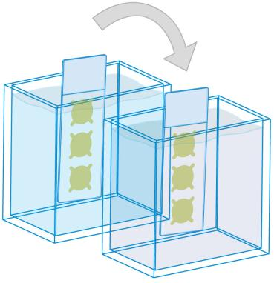
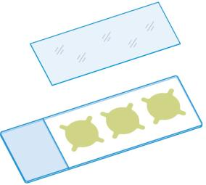

Instructions
3WellChamber,removable
• Perform your standard staining protocol (ﬁxation,
permeabilization, staining, washing) in the single
wells(1).
• Starting from one edge, remove the silicone gasket
byhandorbyusingtweezers(2).
(1)
(3)
Mounting:
Mounttheslidewithacoverslip24mm×60mm(ibidi,
10811)andapermanentmountingmediumofyourchoice
(4).
(2)
Note:
Ifyouwanttoreducethevolumeofthestainingsolu-
tionneeded,usetheroundcoverslipasshowninthe
coversliphandlingprotocol.Washthewellbyadding
950µlandremovingthecoverslip.
(4)
Paralleltechnique:
Tip:
All necessary steps (ﬁxation, permeabilization, staining,
washing)arecarriedoutbydippingthewholeslideinto
thesolutionsafterremovingthesiliconegasket(4).
For mounting of slide samples, a hardening per-
manent mounting medium such as Fluoroshield™
(Sigma-Aldrich), Vectashield® (Vector Laboratories
Inc.)orProLong®Antifade(ThermoFisherScientiﬁc)
isrecommended.
• Starting from one edge, remove the silicone gasket
byhandorbyusingtweezers(2).
ibidiMountingMediumisnotrecommendedbecause
itisnon–hardeningandstaysaliquid(whichisad-
vantageousforµ–Slidesandµ–Dishes).
• Perform your standard staining protocol (ﬁxation,
permeabilization,staining,washing)bydippingthe
slideintothesolutions(3).
3WellChamber,removable
Page3
Version1.0(2016-02-02)

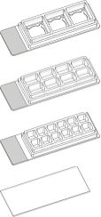
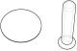
Instructions
3WellChamber,removable
OrderingInformation
Cat.No.
Description
80381
3WellChamber,removable:microscopyglassslide,sterilized
80841
81201
10811
10815
8WellChamber,removable:microscopyglassslide,sterilized
12WellChamber,removable:microscopyglassslide,sterilized
Coverslips60mm,unsterileforChambers,removable,#1.5H(170±5µm)D263MSchottglass,24mm×
Coverslips and Coverslip Pick-Up Tool for 3Well Chamber, removable: # 1.5H (170 ±
5µm)D263MSchottglass,15mm,unsterile,includingonesiliconerubbertoolforconve-
nientglasscoversliphandling
Forresearchuseonly!
FurthertechnicalspeciﬁcationscanbefoundatForquestionsandsuggestionspleasecontactusbye-mailinfo@ibidi.de
orbytelephone+49(0)89/52046170.AllproductsaredevelopedandproducedinGermany.
©ibidiGmbH,AmKlopferspitz19,82152Martinsried,Germany.
3WellChamber,removable
Page4
Version1.0(2016-02-02)

