
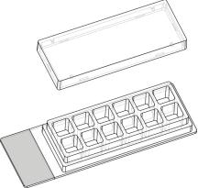
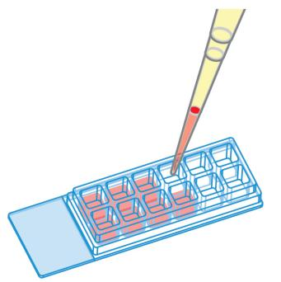
Instructions
12wellChamber,removable
The 12 well Chamber, removable is a removable silicone chamber for cell culture and
immunoﬂuorescence stainings. It allows the use of standard cultivation, staining and
mountingtechniqueswithcoverslipsealing. 12wellChamber,removablesupportsup-
rightmicroscopyandlong-termstorageofcellculturemicroscopysamplesaftermount-
ingtheglassslidewithacoverslip1. 12wellChamber,removableisnotrecommended
forlivecellmicroscopyoninvertedmicroscopessincecellsgrowona1mmmicroscopy
glassslide.
1Suitable24mm×60mmcoverslipsareprovidedbyibidi(10811).
Material
SeedingCells
The 12 well Chamber, removable is comprised of a self–
adhesive 12 well silicone gasket mounted on a standard
microscopyglassslide. Thegasketismanufacturedfrom
biocompatiblesiliconematerial. Althoughbothmaterials
areautoclavableandcompatiblewithalcohols,wedonot
recommendreusingthem.
Trypsinize and count cells as usual. Dilute the cell sus-
pensiontothedesiredconcentration. Dependingonyour
celltype,applicationofa4-9×104 cells/mlsuspension
shouldresultinaconﬂuentlayerwithin2-3days.
• Apply250µlcellsuspensionintoeachwell. Avoid
shakingasthiswillresultininhomogeneousdistri-
butionofthecells.
Geometry
• Coverwellswiththesuppliedlid. Incubateat37°C
and5%CO2asusual.
12wellChamber,removableprovidesastandardslidefor-
mataccordingtoISO8037/1.
Undemanding cells can be left in their seeding medium
foruptothreedaysandgrowtoconﬂuencethere. How-
ever, best results might be achieved when the medium
is changed every 1–2 days. Carefully aspirate the old
mediumandreplaceitby250µl/wellfreshmedium.
Geometryofthe12wellChamber,removable
Numberofwells
12
Dimensionofwells(w×l×h) 7.5×7.5×8
inmm
Volumeperwell
250µl
Totalheightwithlid
Growthareaperwell
Coatingareaperwell
Bottommaterial,sizeinmm
11mm
0.56cm2
1.9cm2
standard glass slide
26 × 76 × 1, ground
edges,
twin frosted
ends13mm
SurfacesandCoatings
12wellChamber,removableismountedonanuncoated
glass slide with twin frosted ends. Speciﬁc coatings on
glassarepossiblefollowingthisprotocol:
• Prepareyourcoatingsolutionaccordingtotheman-
ufacturer’sspeciﬁcationsorreference.
SolventsforFixation,StainingandOtherPur-
poses
• Apply250µlperwellandleaveatroomtemperature
foratleast30minutes.
12 well Chamber, removable is compatible to methanol,
acetone,acids,alkalis,PFA,DMSO,siliconeoil,andmin-
eraloilforcellculture.
• Aspiratethesolutionandwashwithultra-purewa-
ter.Letdryatroomtemperature.
12wellChamber,removable
Page1
Version2014-12-10

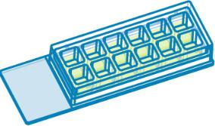
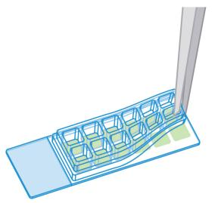
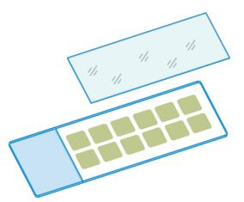
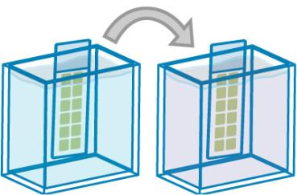

Instructions
12wellChamber,removable
ImmunoﬂuorescenceMicroscopy
• Mountslideandcoverslipwithapermanentmount-
ingmediumofyourchoiceandacoverslip24mm×
60mm(10811)(3).
Aftercultivation,cellscanbeﬁxedandstainedbeforeor
afterremovingthesiliconegasket.
Singlewelltechnique:
• Carryoutallnecessarysteps(ﬁxation,permeabiliza-
tion,staining,washing)insinglewells(1).
• Starting from one edge, remove the silicone gasket
byhandortweezers(2).
• Mountslidewithapermanentmountingmediumof
yourchoiceanda24mm×60mmcoverslip(10811)
(3).
(4)
ibidiMountingMediumisnotrecommendedfor12well
Chamber, removable because it is non–hardening and
staysaliquid(whichisadvantageousforµ–Slidesandµ–
Dishes).
Tips:
(1)
Thedaybeforeseedingthecellswerecommendplac-
ingthecellmediumandslidesintotheincubatorfor
equilibration. Thiswillpreventtheliquidinsidethe
slideorchannelfromcreatingairbubblesoverthein-
cubationtime.
Formountingofslidesamples,apermanentmount-
ing medium is recommended.
ibidi Mounting
Medium is not recommended because it is non–
hardeningandstaysaliquid(whichisadvantageous
forµ–Slidesandµ–Dishes).
(2)
ShippingandStorage
The µ–Slides, µ–Dishes and µ–Plates are sterilized and
weldedinagas-permeablepackaging.Theshelflifeunder
proper storage conditions (in a dry place, no direct sun-
light)islistedinthefollowingtable.
Conditions
(3)
Shippingconditions
Storageconditions
Ambient
Paralleltechnique:
RT(15-25°C)
• Starting from one edge, remove the silicone gasket
byhandortweezers(2).
ShelfLifeofDifferentSurfaces
• Carryoutallnecessarysteps(ﬁxation,permeabiliza-
tion,staining,washing)dippingtheslideintotheso-
lutions. Acoverslip(24mm×60mm)canbeused
duringstainingforreducingthevolume(4).
ibiTreat,glassbottom,ESS
36months
18months
4months
Collagen,Poly-Lysine
Fibronectin
12wellChamber,removable
Page2
Version2014-12-10

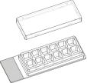
Instructions
12wellChamber,removable
12wellChamber,removableFamily
Cat.No.
Description
Characteristics
81201
10811
12wellChamber,removable:microscopyglassslide
sterilized
unsterile
Coverslipsfor12wellChamber,removable,#1.5H(170± 5µm)
D263MSchottglass,24mm×60mm
12wellChamber,removable
Page3
Version2014-12-10

Instructions
12wellChamber,removable
Forresearchuseonly!
FurthertechnicalspeciﬁcationscanbefoundatForquestionsandsuggestionspleasecontactusbye-mailinfo@ibidi.de
orbytelephone+49(0)89/52046170.AllproductsaredevelopedandproducedinGermany.
©ibidiGmbH,AmKlopferspitz19,82152Martinsried,Germany.
12wellChamber,removable
Page4
Version2014-12-10

