
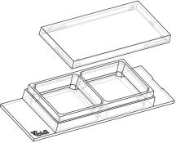

Instructions
µ–Slide2Well Ph+
Theibidiproductfamilyiscomprisedofavarietyofµ–Slidesandµ–Dishes,whichhave
all been designed for high–end microscopic analysis of ﬁxed or living cells. The high
opticalqualityofthematerialissimilartothatofglass,soyoucanperformallkindsof
ﬂuorescenceexperimentswithuncompromisedresolutionandchoiceofwavelength.
Theµ–Slide2WellPh+(Phasecontrastplus)isanarrayof2squareﬁeldswherecellscanbe
cultivatedandinvestigatedwithmicroscopicalmethods.Theµ–Slide2WellPh+improves
theopticalqualityofphasecontrastmicroscopy. Incontrasttotheclassicµ–Slide2Well,
thePh+versionprovidesaspecialplateinthecenterofthewells. Thisplatesuppresses
themeniscuswhichisdisturbingthephasecontrasteffectinnormalopenwells.Openingsnearthecornersprovideaccess
tothewellsforﬁllingandaspiratingliquidseasily.
Material
ShelfLifeofDifferentSurfaces
ibiTreat,GlassBottom,ESS
Collagen,Poly-Lysine
Fibronectin
36months
18months
4months
ibidiµ–Slides,µ–Dishes,andµ–Platesaremadeofaplas-
ticthathasthehighestopticalquality. Thepolymercov-
ersliponthebottomexhibitsextremelylowbirefringence
and autoﬂuorescence, similar to that of glass. Also, it is
not possible to detach the bottom from the upper part.
Theµ–Slides,µ–Dishes,andµ–Platesarenotautoclavable,
sincetheyareonlytemperature–stableupto80°C/175°F.
Please note that gas exchange between the medium and
incubator’satmosphereoccurspartiallythroughthepoly-
mercoverslip,whichshouldnotbecovered.
Geometry
Theµ–Slide2WellPh+providesastandardslideformatac-
cordingtoISO8037/1.
Geometryofµ–Slide2WellPh+
OpticalPropertiesibidiPolymerCoverslip
Numberofwells
2
RefractiveindexnD(589nm)
Abbenumber
1.52
Dimensionsofwells(w×l×h)inmm 21.2 × 23.3 ×
3.0
56
Thickness
No.1.5(180µm)
polymercoverslip
Growthareaperwell
Coatingareaperwell
Volumeperwell
4.8cm2
11.4cm2
Material
1.5ml
Pleasenote! Theibidipolymercoverslipiscompatible
withcertaintypesofimmersionoilonly. Alistofsuit-
ableoilscanbefoundonpage3.
Liquidheight
3.0mm
10.8mm
No.1.5
Totalheightwithlid
Bottommatchescoverslip
µ–SlideSurfaces
ShippingandStorage
Dependingonthetypeofcellsandthespecialapplication
youareusing,youwillneedµ–Slideswithdifferentsur-
faces.Ifyoudonotrequireanyspecialadhesionmolecules
foryourapplication,thebestchoicewillbeibiTreat,atis-
sueculturetreatedsurface.
The µ–Slides, µ–Dishes and µ–Plates are sterilized and
weldedinagas-permeablepackaging.Theshelflifeunder
proper storage conditions (in a dry place, no direct sun-
light)islistedinthefollowingtable.
Weprovideprecoatedµ–Slideswithadhesionsubstrates
likeCollagenIV,Fibronectin,Poly–L–Lysin,andPoly–D–
Lysin.Suchadhesionsubstrateshavebeenshowntostim-
ulatetheadhesionandgrowthofvariouscelllinesinµ–
Slides.Onlyhigh–qualitysubstratesareused1.
Conditions
Shippingconditions
Storageconditions
Ambient
RT(15-25°C)
1CollagenIV:Corning#356233,Fibronectin:Corning#354008,Poly–L–Lysin:Sigma#P4832,Poly–D–Lysin:Corning#354210
µ–Slide2WellPh+
Page1
Version2.0(2015-11-22)


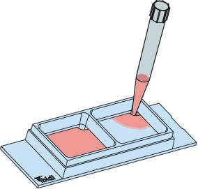
Instructions
µ–Slide2Well Ph+
Theuncoatedµ–Slideismanufacturedfromhydrophobic
plastic. For the cultivation of most cell lines, it is indis-
pensabletotreattheuncoatedµ–Slidewithbiopolymers,
whichmediatecelladhesionandgrowth.
Tip:
Thedaybeforeseedingthecellswerecommendplac-
ingthecellmediumandtheµ–Slideintotheincubator
forequilibration. Thiswillpreventtheliquidinside
fromemergingairbubblesovertheincubationtime.
Coatingyourµ–Slide2Well Ph+
Theuncoatedµ–Slidemustbecoatedtopromotecellad-
hesion.Ifyouwanttoestablishacertaincoatingtomatch
your needs, we recommend testing your coating proce-
dure on both uncoated and ibiTreat µ–Slides, since we
haveobservedthatsomebiomoleculesadheredifferently
tohydrophobicandhydrophilicplasticsurfaces.
FillingandHandling
Fill the wells by using a standard pipet. Inject the cell
suspensiondirectlyintooneoftheopenings.Mediumex-
changeiseasilydonebyaspiratingtheentirevolumeand
reﬁllingusing1.5mlperwell.
• Prepareyourcoatingsolutionaccordingtotheman-
ufacturer’sspeciﬁcationsorreference.
• Apply1.5mlperwellandleaveatroomtemperature
foratleast30minutes.
• Aspirate the solution and wash with the recom-
mendedproteindilutionbuffer.
• Optionallyletdryatroomtemperature. Attention,
somecoatingproteinsmightdegeneratewhendry-
ing!
DetailedinformationaboutcoatingsisprovidedinAppli-
cationNote08
SeedingCells
• Trypsinizeandcountcellsasusual. Dilutethecell
suspensiontothedesiredconcentration.Depending
onyourcelltype,applicationofa5-11×104cells/ml
suspensionshouldresultinaconﬂuentlayerwithin
2–3days.
• Apply1.5mlcellsuspensionintoeachwelloftheµ–
Slide.Avoidshakingasthiswillresultininhomoge-
neousdistributionofthecells.
• Cover the slide with the supplied lid. Incubate at
37°Cand5%CO2asusual.
Undemanding cells can be left in their seeding medium
foruptothreedaysandgrowtoconﬂuencethere. How-
ever, best results might be achieved when the medium
is changed every 1–2 days. Carefully aspirate the old
mediumandreplaceitby1.5ml/wellfreshmedium.
µ–Slide2WellPh+
Page2
Version2.0(2015-11-22)

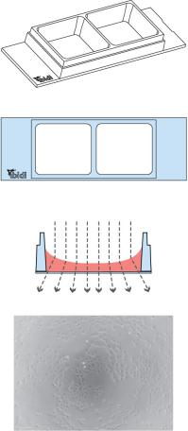
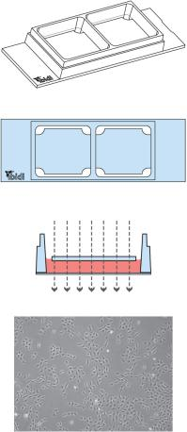
Instructions
µ–Slide2Well Ph+
PreparationforCellMicroscopy
µ–Slide2well Ph+selectionguide
µ–Slide2Well
µ–Slide2WellPh+
To analyze your cells, no special preparations are neces-
sary.Cellscanbeobservedlive,orﬁxeddirectlyintheµ–
Slideonaninvertedmicroscope. Youcanuseanyﬁxative
of your choice. The µ–Slide material is compatible with
avarietyofchemicals,e.g.,acetoneormethanol. Further
speciﬁcationscanbefoundatDuetothe
thinbottomofonly180µm,highresolutionmicroscopyis
possible.
Standard open wells for maxi- Specialplateinthecenterofthe
mum sample access.
Meniscus
wells suppresses meniscus for-
mation. Nomeniscus–parallel
disturbs the beam path.
Good
phasecontrastqualityonlyinthe beampath. Forexcellentphase
centerofeachwell
contrastmicroscopyalloverthe
wells.
ImmersionOil
When using oil immersion objectives, use only the im-
mersion oils speciﬁed in the table. The use of a non–
recommendedoilcouldleadtothedamageoftheplastic
materialandtheobjective.
Company
Product
OrderingNumber
Zeiss
Zeiss
Leica
Immersol518F
ImmersolW2010
Immersionliquid
(Zeiss)444960
(Zeiss)444969
(Leica)11513859
µ–Slide2WellPh+
Page3
Version2.0(2015-11-22)

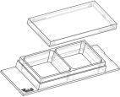
Instructions
µ–Slide2Well Ph+
OrderingInformation
Theµ–Slide2WellisavailableasopenwellandasaPh+version,aswellasinaglassbottomversion. Seetablebelowfor
choosingyourµ–Slide2Well.
µ–Slide2Well
Cat.No.
Description
80886
80882
80883
80884
80885
80881
80887
µ–Slide2WellibiTreat:#1.5polymercoverslip,tissueculturetreated,sterilized
µ–Slide2WellCollagenIV:#1.5polymercoverslip,sterilized
µ–Slide2WellFibronectin:#1.5polymercoverslip,sterilized∗
µ–Slide2WellPoly-L-Lysine:#1.5polymercoverslip,sterilized
µ–Slide2WellPoly-D-Lysine:#1.5polymercoverslip,sterilized∗
µ–Slide2WellUncoated:#1.5polymercoverslip,hydrophobic,sterilized
µ–Slide2WellGlassBottom:1.5H(170µm±5µm)D263MSchottglass,sterilized
∗availableonrequestonly
µ–Slide2WellPh+
Cat.No.
Description
80296
80292
80293
80294
80295
80291
80297
µ–Slide2WellPh+ibiTreat:#1.5polymercoverslip,tissueculturetreated,sterilized
µ–Slide2WellPh+CollagenIV:#1.5polymercoverslip,sterilized
µ–Slide2WellPh+Fibronectin:#1.5polymercoverslip,sterilized∗
µ–Slide2WellPh+Poly-L-Lysine:#1.5polymercoverslip,sterilized
µ–Slide2WellPh+Poly-D-Lysine:#1.5polymercoverslip,sterilized∗
µ–Slide2WellPh+Uncoated:#1.5polymercoverslip,hydrophobic,sterilized
µ–Slide2WellPh+GlassBottom:1.5H(170µm±5µm)D263MSchottglass,sterilized
∗availableonrequestonly
Forresearchuseonly!
FurthertechnicalspeciﬁcationscanbefoundatForquestionsandsuggestionspleasecontactusbye-mailinfo@ibidi.de
orbytelephone+49(0)89/52046170.AllproductsaredevelopedandproducedinGermany.
©ibidiGmbH,AmKlopferspitz19,82152Martinsried,Germany.
µ–Slide2WellPh+
Page4
Version2.0(2015-11-22)

