
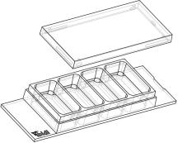

Instructions
µ–Slide4well Ph+
Theibidiproductfamilyiscomprisedofavarietyofµ–Slidesandµ–Dishes,whichhave
all been designed for high–end microscopic analysis of ﬁxed or living cells. The high
opticalqualityofthematerialissimilartothatofglass,soyoucanperformallkindsof
ﬂuorescenceexperimentswithuncompromisedresolutionandchoiceofwavelength.
Theµ–Slide4wellPh+(Phasecontrastplus)isanarrayof4squareﬁeldswherecellscanbe
cultivatedandinvestigatedwithmicroscopicalmethods.Theµ–Slide4wellPh+improves
theopticalqualityofphasecontrastmicroscopy. Incontrasttotheclassicµ–Slide4well,
thePh+versionprovidesaspecialplateinthecenterofthewells. Thisplatesuppresses
themeniscuswhichisdisturbingthephasecontrasteffectinnormalopenwells.Openingsnearthecornersprovideaccess
tothewellsforﬁllingandaspiratingliquidseasily.
Material
plastic. For the cultivation of most cell lines, it is indis-
pensabletotreattheuncoatedµ–Slidewithbiopolymers,
whichmediatecelladhesionandgrowth.
ibidiµ–Slides,µ–Dishes,andµ–Platesaremadeofaplas-
tic that has the highest optical quality. The bottom ma-
terial exhibits extremely low birefringence and autoﬂuo-
rescence, similar to that of glass. Also, it is not possible
todetachthebottomfromtheupperpart. Theµ–Slides,
µ–Dishes, and µ–Plates are not autoclavable, since they
areonlytemperature–stableupto80°C/175°F.Pleasenote
that gas exchange between the medium and incubator’s
atmosphere occurs partially through the plastic bottom,
whichshouldnotbecovered.
Geometry
Theµ–Slide4wellPh+providesastandardslideformatac-
cordingtoISO8037/1.
Geometryofµ–Slide4wellPh+
Numberofwells
4
OpticalPropertiesibidiStandardBottom
Dimensionsofwells(w×l×h)inmm 21.2 × 11.0 ×
3.0
RefractiveindexnD(589nm)
Abbenumber
1.52
Growthareaperwell
Coatingareaperwell
Volumeperwell
2.2cm2
5.9cm2
56
Thickness
No.1.5(180µm)
microscopyplastic
700µl
Material
Liquidheight
3.0mm
10.8mm
No.1.5
Totalheightwithlid
Bottommatchescoverslip
Please note! The ibidi standard bottom is compatible
withcertaintypesofimmersionoilonly. Alistofsuit-
ableoilscanbefoundonpage3.
Coatingyourµ–Slide4well Ph+
µ–SlideSurfaces
Theuncoatedµ–Slidemustbecoatedtopromotecellad-
hesion.Ifyouwanttoestablishacertaincoatingtomatch
your needs, we recommend testing your coating proce-
dure on both uncoated and ibiTreat µ–Slides, since we
haveobservedthatsomebiomoleculesadheredifferently
tohydrophobicandhydrophilicplasticsurfaces.
Dependingonthetypeofcellsandthespecialapplication
youareusing,youwillneedµ–Slideswithdifferentsur-
faces.Ifyoudonotrequireanyspecialadhesionmolecules
foryourapplication,thebestchoicewillbeibiTreat,atis-
sueculturetreatedsurface.
• Prepareyourcoatingsolutionaccordingtotheman-
ufacturer’sspeciﬁcationsorreference.
Weprovideprecoatedµ–Slideswithadhesionsubstrates
likeCollagenIV,Fibronectin,Poly–L–Lysin,andPoly–D–
Lysin.Suchadhesionsubstrateshavebeenshowntostim-
ulatetheadhesionandgrowthofvariouscelllinesinµ–
Slides.Onlyhigh–qualitysubstratesareused1.
• Apply700µlperwellandleaveatroomtemperature
foratleast30minutes.
• Aspirate the solution and wash with the recom-
mendedproteindilutionbuffer.
Theuncoatedµ–Slideismanufacturedfromhydrophobic
1CollagenIV:Corning#356233,Fibronectin:Corning#354008,Poly–L–Lysin:Sigma#P4832,Poly–D–Lysin:Corning#354210
µ–Slide4wellPh+
Page1
Version2014-05-14


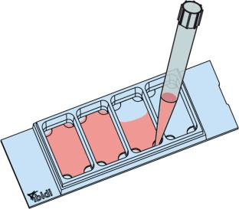
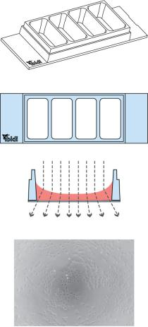
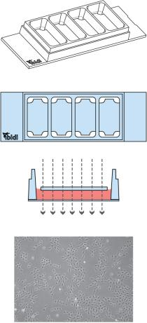
Instructions
µ–Slide4well Ph+
µ–Slide4well Ph+selectionguide
• Optionallyletdryatroomtemperature. Attention,
somecoatingproteinsmightdegeneratewhendry-
ing!
µ–Slide4well
µ–Slide4wellPh+
Standard open wells for maxi- Specialplateinthecenterofthe
mum sample access.
Meniscus
wells suppresses meniscus for-
mation. Nomeniscus–parallel
Seedingcells
disturbs the beam path.
Good
phasecontrastqualityonlyinthe beampath. Forexcellentphase
• Trypsinizeandcountcellsasusual. Dilutethecell
suspensiontothedesiredconcentration.Depending
onyourcelltype,applicationofa5-11×104cells/ml
centerofeachwell
contrastmicroscopyalloverthe
wells.
suspensionshouldresultinaconﬂuentlayerwithin
2–3days.
• Apply700µlcellsuspensionintoeachwelloftheµ–
Slide.Avoidshakingasthiswillresultininhomoge-
neousdistributionofthecells.
• Cover the slide with the supplied lid. Incubate at
37°Cand5%CO2asusual.
Undemanding cells can be left in their seeding medium
foruptothreedaysandgrowtoconﬂuencethere. How-
ever, best results might be achieved when the medium
is changed every 1–2 days. Carefully aspirate the old
medium and replace it by 700µl/well fresh medium.
Tip:
Thedaybeforeseedingthecellswerecommendplac-
ingthecellmediumandtheµ–Slideintotheincubator
forequilibration. Thiswillpreventtheliquidinside
fromemergingairbubblesovertheincubationtime.
FillingandHandling
Fill the wells by using a standard pipet. Inject the cell
suspensiondirectlyintooneoftheopenings.Mediumex-
changeiseasilydonebyaspiratingtheentirevolumeand
reﬁllingusing700µlperwell.
µ–Slide4wellPh+
Page2
Version2014-05-14

Instructions
µ–Slide4well Ph+
PreparationforCellMicroscopy
ImmersionOil
When using oil immersion objectives, use only the im-
mersion oils speciﬁed in the table. The use of a non–
recommendedoilcouldleadtothedamageoftheplastic
materialandtheobjective.
To analyze your cells, no special preparations are neces-
sary.Cellscanbeobservedlive,orﬁxeddirectlyintheµ–
Slideonaninvertedmicroscope. Youcanuseanyﬁxative
ofyourchoice. Theµ–Slidematerialiscompatiblewitha
varietyofchemicals(e.g.,AcetoneorMethanol). Further
speciﬁcationscanbefoundatDuetothe
thinbottomofonly180µm,highresolutionmicroscopyis
possible.
Company
Product
OrderingNumber
ibidi
Zeiss
Zeiss
Leica
ImmersionOil
(ibidi)50101
Immersol518F
ImmersolW2010
Immersionliquid
(Zeiss)444960
(Zeiss)444969
(Leica)11513859
µ–Slide4wellPh+
Page3
Version2014-05-14

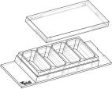
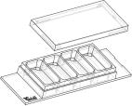
Instructions
µ–Slide4well Ph+
µ–Slide4wellFamily
Theµ–Slide4wellfamilyisavailableasopenwellandasaPh+version.Seetablebelowforchoosingyourµ–Slide4well.
µ–Slide4well
OrderingNumber TreatmentorCoating
Characteristics
80426
80422
80423
80424
80425
80421
80427
ibiTreat,sterile
hydrophilic,tissueculturetreated
proteincoating
CollagenIV,sterile
Fibronectin,sterile∗
Poly-L-Lysine,sterile
proteincoating
biopolymercoating
Poly-D-Lysine,sterile∗
uncoated,sterile
glassbottom
biopolymercoating
hydrophobic
glasscoverslipNo.1.5H(170µm±5µm)
µ–Slide4wellPh+
OrderingNumber TreatmentorCoating
Characteristics
80446
80442
80443
80444
80445
80441
80447
ibiTreat,sterile
hydrophilic,tissueculturetreated
proteincoating
CollagenIV,sterile
Fibronectin,sterile∗
Poly-L-Lysine,sterile
proteincoating
biopolymercoating
Poly-D-Lysine,sterile∗
uncoated,sterile
glassbottom
biopolymercoating
hydrophobic
glasscoverslipNo.1.5H(170µm±5µm)
∗availableonrequestonly
Forresearchuseonly!
FurthertechnicalspeciﬁcationscanbefoundatForquestionsandsuggestionspleasecontactusbye-mailinfo@ibidi.de
orbytelephone+49(0)89/52046170.AllproductsaredevelopedandproducedinGermany.
©ibidiGmbH,AmKlopferspitz19,82152Martinsried,Germany.
µ–Slide4wellPh+
Page4
Version2014-05-14

