
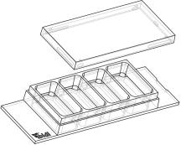
Instructions
µ–Slide4well Ph+glassbottom
Theibidiproductfamilyiscomprisedofavarietyofµ–Slidesandµ–Dishes,whichhave
allbeendesignedforhigh–endmicroscopicanalysisofﬁxedorlivingcells.
Theglassbottomversionsoftheµ–Slidesandµ–DishesareespeciallydesignedforTIRF
andsinglemoleculeapplications.
Theµ–Slide4wellPh+(Phasecontrastplus)isanarrayof4squareﬁeldswherecellscanbe
cultivatedandinvestigatedwithmicroscopicalmethods.Theµ–Slide4wellPh+improves
theopticalqualityofphasecontrastmicroscopy. Incontrasttotheclassicµ–Slide4well,
thePh+versionprovidesaspecialplateinthecenterofthewells. Thisplatesuppresses
themeniscuswhichisdisturbingthephasecontrasteffectinnormalopenwells.Openingsnearthecornersprovideaccess
tothewellsforﬁllingandaspiratingliquidseasily.
Material
Geometry
The glass bottom version of the µ–Slides are made of a
standardµ–Slidebutwithaglasscoverslipbottom. Itis
not possible to detach the bottom. The µ–Slides are not
autoclavablesincetheyaretemperaturestableonlyupto
80°C/175°F.
The µ–Slide 4well Ph+glass bottom provides a standard
slideformataccordingtoISO8037/1.
Geometryofµ–Slide4wellPh+glassbottom
Numberofwells
4
OpticalPropertiesibidiglassbottom
Dimensionsofwells(w×l×h)inmm 21.2 × 11.0 ×
3.0
RefractiveindexnD
Abbenumber
1.523
55
Growthareaperwell
Coatingareaperwell
Volumeperwell
2.2cm2
5.9cm2
Thickness
No.1.5H(selectedquality
170µm,±5µm)
700µl
Material
Schottborosilicateglass,
D263M
Liquidheight
3.0mm
10.8mm
No.1.5
Totalheightwithlid
Bottommatchescoverslip
Surfaceandcoating
Theµ–Slide4well Ph+glassbottomismanufacturedwith
anuncoatedglasscoverslip.Washingsteps(e.g.withPBS)
beforecellseedingcanremoveglassdustwhichisadvan-
tageousfordirectcellgrowthonthesurface.
Seedingcells
• Trypsinizeandcountcellsasusual. Dilutethecell
suspensiontothedesiredconcentration.Depending
onyourcelltype,applicationofa5-11×10 cells/ml
suspensionshouldresultinaconﬂuentlayerwithin
2–3days.
Protein coatings increase direct cell growth of adherent
cells.Speciﬁccoatingsonglassarepossiblefollowingthis
protocol:
4
• Prepareyourcoatingsolutionaccordingtotheman-
ufacturer’sspeciﬁcationsorreference. Prepareyour
µ–Slide.Adjusttheconcentrationtoacoatingareaof
5.9cm2and700µl.
• Apply700µlcellsuspensionintoeachwelloftheµ–
Slide.Avoidshakingasthiswillresultininhomoge-
neousdistributionofthecells.
• Apply700µlintothegrowtharea. Makesurethat
theentirebottomiscoveredwithliquideasilytilting
orshakingtheµ–Slide. Putonthelidandleaveat
roomtemperatureforatleast30minutes.
• Cover the slide with the supplied lid. Incubate at
37°Cand5%CO2asusual.
Undemanding cells can be left in their seeding medium
foruptothreedaysandgrowtoconﬂuencethere. How-
ever, best results might be achieved when the medium
is changed every 1–2 days. Carefully aspirate the old
medium and replace it by 700µl/well fresh medium.
• Aspirate the solution and wash with the recom-
mendedproteindilutionbuffer. Optionally, letdry
atroomtemperature. Attention, somecoatingpro-
teinsmightdegeneratewhendrying!
µ–Slide4wellPh+glassbottom
Page1
Version2014-05-14


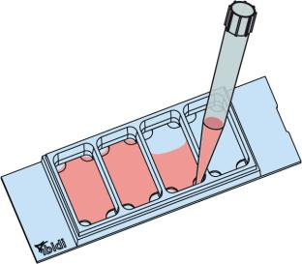
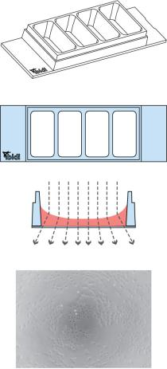
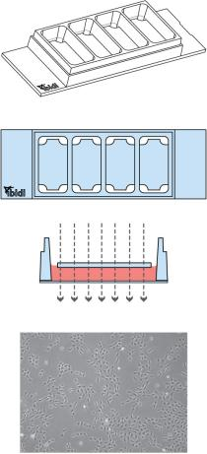
Instructions
µ–Slide4well Ph+glassbottom
µ–Slide4well Ph+selectionguide
Tip:
µ–Slide4well
µ–Slide4wellPh+
Thedaybeforeseedingthecellswerecommendplac-
ingthecellmediumandtheµ–Slideintotheincubator
forequilibration. Thiswillpreventtheliquidinside
fromemergingairbubblesovertheincubationtime.
Standard open wells for maxi- Specialplateinthecenterofthe
mum sample access.
Meniscus
wells suppresses meniscus for-
mation. Nomeniscus–parallel
disturbs the beam path.
Good
phasecontrastqualityonlyinthe beampath. Forexcellentphase
centerofeachwell
contrastmicroscopyalloverthe
wells.
SolventsforFixationandStaining
Cellscanbeobservedliveorﬁxeddirectlyintheµ–Slide
preferablyonaninvertedmicroscope.Theslidematerialis
compatibletoacids,alkalis,PFA,andsiliconeoil.Alcohols
maybeusedforshorttermincubation(e.g. cellﬁxation).
Acetoneisnotcompatible. Furtherspeciﬁcationscanbe
foundat
For optimal results in ﬂuorescence microscopy and stor-
ageofstainedprobesibidiprovidesamountingmedium
(50001)optimizedforµ–Dishesandµ–Slides.
FillingandHandling
Fill the wells by using a standard pipet. Inject the cell
suspensiondirectlyintooneoftheopenings.Mediumex-
changeiseasilydonebyaspiratingtheentirevolumeand
reﬁllingusing700µlperwell.
ImmersionOil
When using oil immersion objectives, use only the im-
mersion oils speciﬁed in the table. The use of a non–
recommendedoilcouldleadtothedamageoftheplastic
materialandtheobjective.
Company
Product
OrderingNumber
ibidi
Zeiss
Zeiss
Leica
ImmersionOil
(ibidi)50101
Immersol518F
ImmersolW2010
Immersionliquid
(Zeiss)444960
(Zeiss)444969
(Leica)11513859
µ–Slide4wellPh+glassbottom
Page2
Version2014-05-14

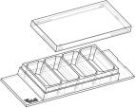
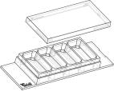
Instructions
µ–Slide4well Ph+glassbottom
µ–Slide4wellFamily
Theµ–Slide4wellfamilyisavailableasopenwellandasaPh+version.Seetablebelowforchoosingyourµ–Slide4well.
µ–Slide4well
OrderingNumber TreatmentorCoating
Characteristics
80426
80422
80423
80424
80425
80421
80427
ibiTreat,sterile
hydrophilic,tissueculturetreated
proteincoating
CollagenIV,sterile
Fibronectin,sterile∗
Poly-L-Lysine,sterile
proteincoating
biopolymercoating
Poly-D-Lysine,sterile∗
uncoated,sterile
glassbottom
biopolymercoating
hydrophobic
glasscoverslipNo.1.5H(170µm±5µm)
µ–Slide4wellPh+
OrderingNumber TreatmentorCoating
Characteristics
80446
80442
80443
80444
80445
80441
80447
ibiTreat,sterile
hydrophilic,tissueculturetreated
proteincoating
CollagenIV,sterile
Fibronectin,sterile∗
Poly-L-Lysine,sterile
proteincoating
biopolymercoating
Poly-D-Lysine,sterile∗
uncoated,sterile
glassbottom
biopolymercoating
hydrophobic
glasscoverslipNo.1.5H(170µm±5µm)
∗availableonrequestonly
µ–Slide4wellPh+glassbottom
Page3
Version2014-05-14

Instructions
µ–Slide4well Ph+glassbottom
Forresearchuseonly!
FurthertechnicalspeciﬁcationscanbefoundatForquestionsandsuggestionspleasecontactusbye-mailinfo@ibidi.de
orbytelephone+49(0)89/52046170.AllproductsaredevelopedandproducedinGermany.
©ibidiGmbH,AmKlopferspitz19,82152Martinsried,Germany.
µ–Slide4wellPh+glassbottom
Page4
Version2014-05-14

