
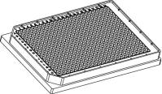

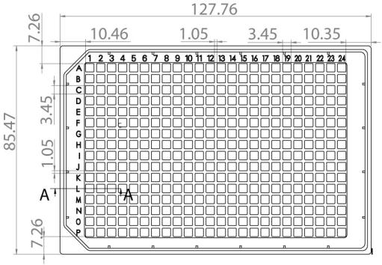
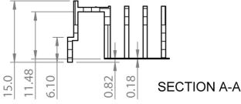
Instructions
µ–Plate384Well
Theibidiproductfamilyiscomprisedofavarietyofµ–Slidesandµ–Dishes,whichhaveallbeen
designedforhigh–endmicroscopicanalysisofﬁxedorlivingcells. Thehighopticalqualityof
thematerialissimilartothatofglass,soyoucanperformallkindsofﬂuorescenceexperiments
withuncompromisedresolutionandchoiceofwavelength.
Theµ–Plate384Wellallowsyoutoperformhighresolutionmicroscopyinastandardmulti–well
format.Forlesswell–to–wellcrosstalkinﬂuorescencemicroscopythisimagingplateismadeout
ofablackplasticmaterial.
Material
Geometryoftheµ–Plate384Well
ibidiµ–Slides,µ–Dishes,andµ–Platesaremadeofaplas-
ticthathasthehighestopticalquality. Thepolymercov-
ersliponthebottomexhibitsextremelylowbirefringence
and autoﬂuorescence, similar to that of glass. Also, it is
not possible to detach the bottom from the upper part.
Theµ–Slides,µ–Dishes,andµ–Platesarenotautoclavable,
sincetheyareonlytemperature–stableupto80°C/175°F.
Please note that gas exchange between the medium and
incubator’satmosphereoccurspartiallythroughthepoly-
mercoverslip,whichshouldnotbecovered.
The µ–Plate 384Well provides standard geometry and
numbering(A-P,1-24).Thebottomoftheµ–Plate384Well
providesahighaccuracy.
OpticalPropertiesibidiPolymerCoverslip
RefractiveindexnD(589nm)
Abbenumber
1.52
56
Thickness
No.1.5(180µm)
polymercoverslip
Material
Pleasenote! Theibidipolymercoverslipiscompatible
withcertaintypesofimmersionoilonly. Alistofsuit-
ableoilscanbefoundonpage3.
The µ–Plate 384Well meets all important values of the
ANSI/SBSStandards(1-2004,2-2004,3-2004and4-2004).
ShippingandStorage
Dimensionsoftheµ–Plate384Wellinmm
The µ–Slides, µ–Dishes and µ–Plates are sterilized and
weldedinagas-permeablepackaging.Theshelflifeunder
proper storage conditions (in a dry place, no direct sun-
light)islistedinthefollowingtable.
Length
127.76
85.47
17.2
±0.2
±0.2
±0.4
±0.4
±0.1
±0.1
Width
Heightwithlid
Heightwithoutlid
Welltowelldistance
Wellclearance
15.0
Conditions
4.50
Shippingconditions
Storageconditions
Ambient
0.82
RT(15-25°C)
ShelfLifeofDifferentSurfaces
ibiTreat,GlassBottom,ESS
36months
18months
Collagen,Poly-L-Lysine
µ–Plate384Well
Page1
Version2.0(2015-12-11)



Instructions
µ–Plate384Well
SeedingCells
SingleWellParametersoftheµ–Plate384Well
Singlewelldimensions
Singlewelldepth
Volume
3.45×3.45±0.1mm
11.48±0.2mm
• Trypsinizeandcountcellsasusual. Dilutethecell
suspensiontothedesiredconcentration.Depending
onyourcelltype,applicationofa1.5-4×10 cells/ml
suspensionshouldresultinaconﬂuentlayerwithin
2–3days.
50µl
0.11cm2
0.80cm2
4
Growtharea
Coatingareausing50µl
• Apply 50µl cell suspension into each single well.
Avoidshakingasthiswillresultininhomogeneous
distributionofthecells.
Accuracyoftheµ–Plate384WellBottom
Innerwellﬂatness
±5µm
±25µm
No.1.5
Wholeplateﬂatness
Bottommatchescoverslip
• Covertheµ–Plate384Wellwiththesuppliedlid.In-
cubateat37°Cand5%CO2asusual.
Surface
Tip:
Werecommendnottoﬁllmorethan50µlintotheµ–
Plate384Wellinordertoavoidliquidcontactingthe
lid.
The µ–Plate 384Well is available with ibiTreat and un-
coatedsurface.TheibiTreatsurfaceisaphysicaltreatment
andoptimizedforadhesionofmostcelltypes. Manycell
linesaswellasprimarycellsweretested.
Undemandingcellscanbeleftintheirseedingmediumfor
severaldaysandgrowtoconﬂuencethere.However,best
results might be achieved when the medium is changed
every 2–3 days. Carefully aspirate the old medium and
replaceitby50µlfreshmedium.
Aspeciﬁccoatingoftheµ–Plate384Wellcanbedoneyour-
self following the procedure in section Coating your µ–
Plate384Well.
Coatingyourµ–Plate384Well
Theuncoatedµ–Plate384Wellmustbecoatedtopromote
celladhesion. Ifyouliketoestablishacertaincoatingfor
yourdemandswerecommendtestingyourcoatingproce-
dureonuncoatedandibiTreatµ–Plate384Well,sincewe
haveobservedthatsomebiomoleculesadheredifferently
tohydrophobicorhydrophilicplasticsurfaces.
Tip:
Youcanstacktheµ–Platestosavespaceinyouincu-
bator.Thiswillnotaffectcellgrowth.Werecommend
making batches with up to 6 plates, due to stability
reasons.
• Prepare your coating solution according to the
manufacturer’sspeciﬁcationsorreference.
• Apply50µlineachwell.Thecoatingareausing50µl
is0.8cm2.
PreparationforCellMicroscopy
• Followyourcoatingprotocol.
Furtherinformationaboutcoatingsareprovidedin

Foranalyzingyourcellsnospecialpreparationsarenec-
essary. Cells can be observed live or ﬁxed directly in
the µ–Plate preferably on an inverted microscope. You
can use any ﬁxative of your choice. The µ–Plate mate-
rial is compatible with a variety of chemicals, e.g. Ace-
toneorMethanol. Furtherspeciﬁcationscanbefoundat
Duetothethinbottomofonly180µm,
highresolutionmicroscopyispossible.
RemovetheProtectionFilmbeforeUsage
Thebottomoftheµ–Plate384Welliscoveredwithaﬁlm
toprotecttheopticalqualityoftheplasticsurface. Please
pullofftheprotectionﬁlmbeforeusage!
µ–Plate384Well
Page2
Version2.0(2015-12-11)

Instructions
µ–Plate384Well
ImmersionOil
Company
Product
OrderingNumber
Zeiss
Zeiss
Leica
Immersol518F
ImmersolW2010
Immersionliquid
(Zeiss)444960
(Zeiss)444969
(Leica)11513859
When using oil immersion objectives, use only the im-
mersion oils speciﬁed in the table. The use of a non–
recommendedoilcouldleadtothedamageoftheplastic
materialandtheobjective.
µ–Plate384Well
Page3
Version2.0(2015-12-11)

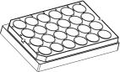
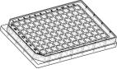
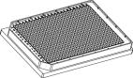
Instructions
µ–Plate384Well
OrderingInformation
Theibidiµ–Platesareavailablewiththefollowingsurfaces.
µ–Plate24Well
Cat.No.
Description
82406
82401
µ–Plate24WellibiTreat:#1.5polymercoverslip,tissueculturetreated,sterilized
µ–Plate24WellUncoated:#1.5polymercoverslip,hydrophobic,sterilized
µ–Plate96Well
Cat.No.
Description
89626
89621
µ–Plate96WellibiTreat:#1.5polymercoverslip,tissueculturetreated,sterilized
µ–Plate96WellUncoated:#1.5polymercoverslip,hydrophobic,sterilized
µ–Plate384Well
Cat.No.
Description
88401
µ–Plate384WellUncoated:#1.5polymercoverslip,hydrophobic,sterilized
Forresearchuseonly!
FurthertechnicalspeciﬁcationscanbefoundatForquestionsandsuggestionspleasecontactusbye-mailinfo@ibidi.de
orbytelephone+49(0)89/52046170.AllproductsaredevelopedandproducedinGermany.
©ibidiGmbH,AmKlopferspitz19,82152Martinsried,Germany.
µ–Plate384Well
Page4
Version2.0(2015-12-11)

