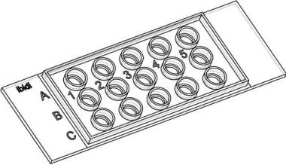
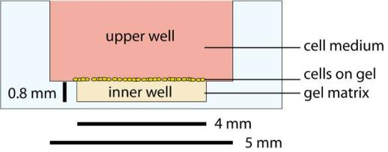

Application Note 19
Tube Formation Assays in µSlide Angiogenesis
Related topics: Application Note 27 “Data Analysis of Tube
Formation Assays”.
Contents
1. General Information ............................................................................................ 1
2. Material............................................................................................................... 2
3. Work Flow Overview .......................................................................................... 3
4. Preparation of the Gel and the Slide.................................................................... 4
Gel Application .................................................................................................... 4
How to Adjust the Right Volume of Gel .............................................................. 5
Gelation ............................................................................................................... 5
5. Seeding Cells ...................................................................................................... 5
5. Seeding Cells ...................................................................................................... 6
6. Observation on the Microscope.......................................................................... 7
Automatical Observation ..................................................................................... 7
Manual Observation ............................................................................................ 7
7. Data Analysis and Interpretation ......................................................................... 7
8. Staining Protocol ................................................................................................. 8
1. General Information
The µ;Slide Angiogenesis is designed for observing tube formation on an inverse
TM
microscope. It can be used with all common gel matrices, such as Matrigel ,
collagen gels, and hyaluronic acid gels. Only 10 µl of gel per well are needed.
The platform provided by µ;Slide Angiogenesis eliminates the meniscus effect,
which is often observed in other well formats. Every cell on the flat gel surface is
visible with high;quality phase contrast or fluorescence microscopy.
µSlide Angiogenesis Cross section of one well
This application note describes a sample setup with the µ;Slide Angiogenesis, which
TM
is being used for tube formation with endothelial cells (HUVEC) on Matrigel .
Application Note 19
© ibidi GmbH, Version 1.3, Helga Wagner, June 25th, 2012
Page 1 of 8

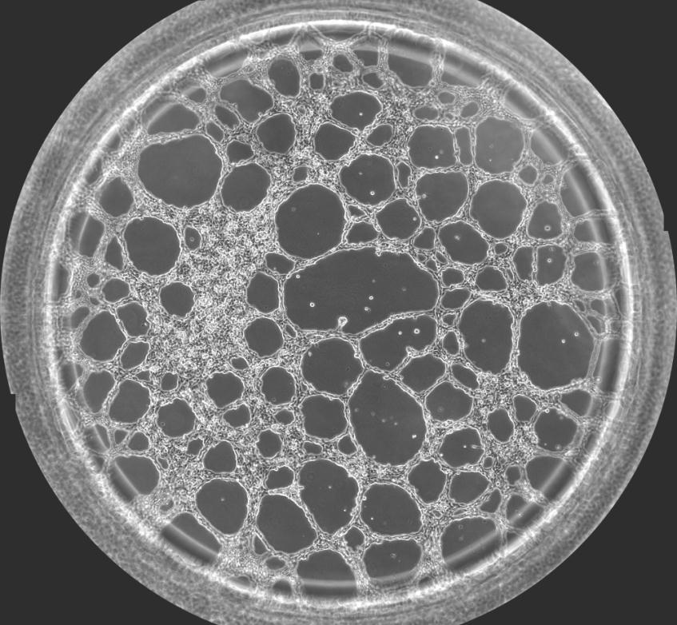
Application Note 19
2. Material
Cells:
Medium:
HUVEC (PromoCell, C;12200, C;12203)
Endothelial Cell Growth Medium
(PromoCell, C;22010)
TM
BD Matrigel (Growth Factor Reduced,
#356231)
10 per well
4
50 µl per well
10 µl per well
Gel Matrix:
Slides:
Fluorescence stain:
µ;Slide Angiogenesis, ibiTreat (ibidi, 81506)
Calcein AM
1 Slide
1 ml (6.25 µg/ml)
(PromoKine, PK;CA707;80011)
Scale paper for checking
Other:
1 sheet
Detach reagent
Accutase (Promocell, C;41310)
8 ml per T75 flask
For easy handling, the wells are compatible with multi;channel pipettes. The plastic
is compatible with various fixing solutions, such as isopropanol, methanol,
paraformaldehyde, and others. The optical properties of the plastic bottom are
comparable to those of glass coverslips.
Phase contrast picture with a 10x objective (arranged of 5x6 single pictures) which shows an
entire well with HUVECs that are forming a cell network. The image was taken 10 hours after
seeding. The diameter of the well is 4 mm.
Application Note 19
© ibidi GmbH, Version 1.3, Helga Wagner, June 25th, 2012
Page 2 of 8

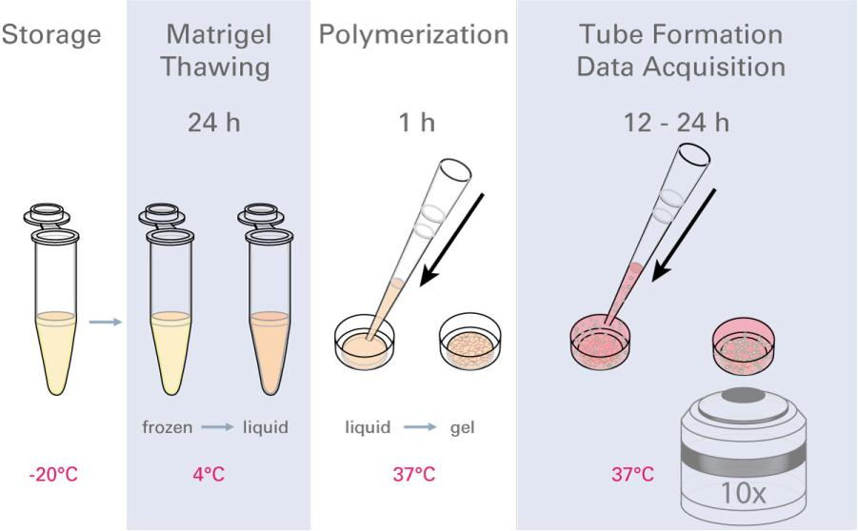
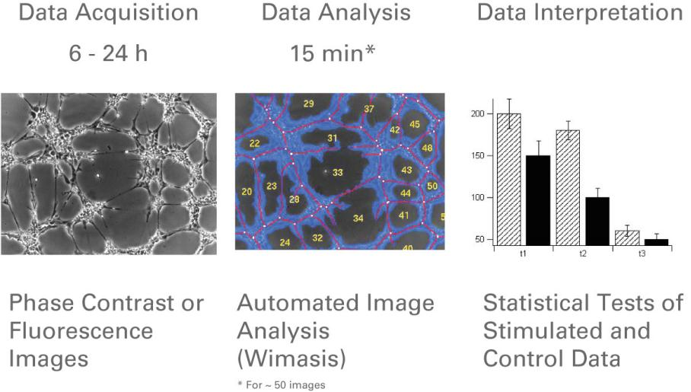
Application Note 19
3. Work Flow Overview
Work flow of practical tasks in the lab. Here, Matrigel is thawed and filled into the lower
well of the µSlide Angiogenesis. After polymerization, cell suspension is applied to the
upper well, and then the network formation is observed microscopically.
Work flow of image processing. Microscopic pictures are taken at several time points
and then are automatically analyzed (e.g., determination of tubes, loops, cell covered
area, and branching points). This data is analyzed with statistical tests to confirm the
result of the experiment.
Application Note 19
© ibidi GmbH, Version 1.3, Helga Wagner, June 25th, 2012
Page 3 of 8

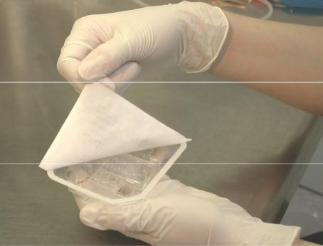
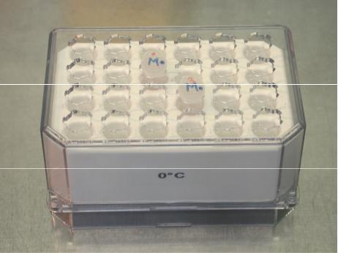
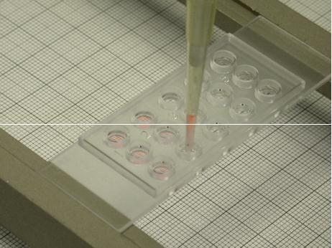

Application Note 19
4. Preparation of the Gel and the Slide
Gel Application
Follow these steps:
TM
1) The day before seeding cells, place the Matrigel on ice in the refrigerator at
4°C. The gel can slowly thaw over night.
Note: Always use precooled pipet tips (4°C) for pipetting the gel!
2) When starting the experiment, place
the vessel with the gel in a cool rack
in the laminar flow.
3) Remove the µ;Slide Angiogenesis
from the sterile packing and place it
on a µ;Slide rack.
4) Apply 10 µl of gel to each inner well.
Hold the pipet tip upright in the
middle of the well. This prevents the
gel from flowing into the upper well.
Pipetting Tips
To avoid air bubbles, make three up
and down movements (10 µl) with the
pipet while leaving the tip in the gel.
Then transfer 10 µl aliquots to the
wells.
Due to the high viscosity of Matrigel ,
TM
it might be necessary to adjust the
pipet volume to more or less then 10
µl.
To control the right amount of gel,
observe the scale paper through the
filled wells. With an adequate volume,
there is no magnification or
minimization effect. If it is not correct,
adjust the volume with gel (see the
following page).
Application Note 19
© ibidi GmbH, Version 1.3, Helga Wagner, June 25th, 2012
Page 4 of 8

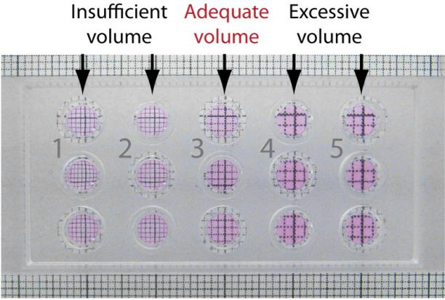
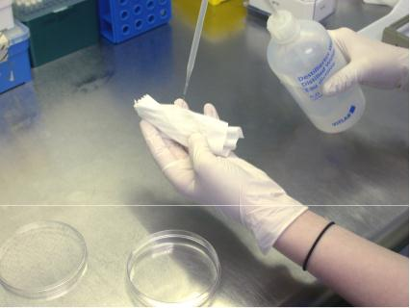
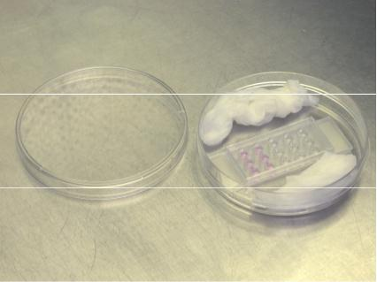
Application Note 19
How to Adjust the Right Volume of Gel
The volume of the inner well is exactly 10 µl. When the well contains the correct
volume, no magnification or demagnification effect, such as seen in the picture
below, is observed. For visualizing the effect, hold the slide at a distance of a few
centimeters over a scale paper.
If the pipet setting of 10 µl does not result in meniscus;free filling, try slightly
different pipetting volumes and check with a scale paper to determine which setting
is adequate.
µSlide
Angiogenesis
filled
with Matrigel. Columns 1 and
2 contain less than 10 µl. The
grid looks diminished. Column
3 is filled with the adequate
volume of 10 µl and shows no
shift. Columns 4 and 5 have an
excessive volume. The grid is
magnified.
Gelation
Follow these steps:
1) After applying the gel, close the lid on the slide.
2) Prepare a petri dish with water soaked paper towels for use as an extra
humidity chamber.
3) Place the µ;Slide in the petri dish and close the lid.
4) Place the whole assembly into the incubator for polymerization (30 min).
5) In the meantime, prepare the cell suspension.
Preparing the humidity chamber
µSlide placed in the humidity chamber
Application Note 19
© ibidi GmbH, Version 1.3, Helga Wagner, June 25th, 2012
Page 5 of 8

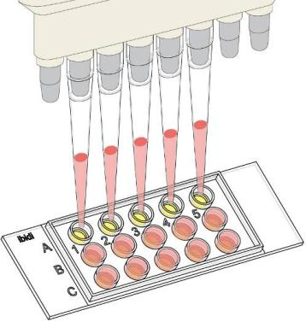
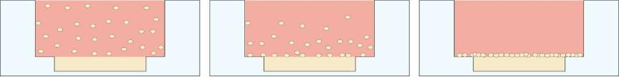
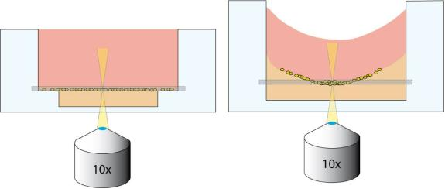
Application Note 19
5. Seeding Cells
The number of cells seeded on the surface of the
gel is a crucial parameter for obtaining reliable
results. The cell type and size determine the
number of cells that are needed. For best results,
optimize the cell seeding number before starting an
experimental series. For a detailed description,
please see Application Note 27 “Data Analysis of
Tube Formation Assays”.
Follow these steps:
1) For a final cell number of 10.000 cells per
well, adjust a cell suspension of
2 · 10 cells/ml. Then mix thoroughly.
5
2) Take the µ;Slide from the incubator and place
it on the rack.
Filling the cell suspension with a
multichannel pipet into the
upper wells.
3) Apply 50 µl cell suspension to each upper well.
Keep the pipet tip upright and take care not to
touch the gel with the pipet tip.
For this step a multi;channel pipet might be
helpful.
4) Again, control the correct volume with the scale paper, as shown above. If
not correct, then adjust the volume with cell;free medium.
5) Close the slide with the lid. The slide is now ready for observation.
6) After some minutes, all the cells will have sunk to the ground and will be
lying in one plane. Due to the geometry of the slides the cells on the margins
are placed on the plastic surface.
Sinking process of cells. After some minutes all of the cells have fallen to the ground.
The cross section of the well now shows two flat surfaces: the Matrigel itself and
TM
the medium above. In comparison to normal well formats no meniscus disturbs the
excellent optical properties.
Comparison between the flat surfaces of a well in µSlide
Angiogenesis and a well from a 96well plate.
Application Note 19
© ibidi GmbH, Version 1.3, Helga Wagner, June 25th, 2012
Page 6 of 8

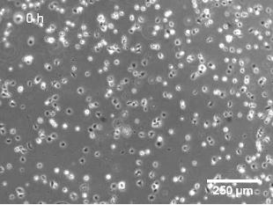
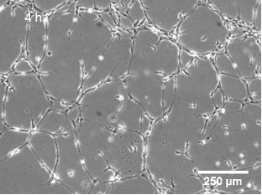
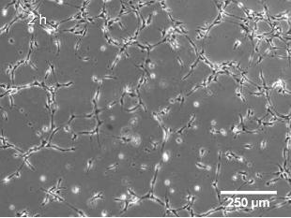
Application Note 19
6. Observation on the Microscope
There are two possible ways to collect data on the microscope, manually or
automatically. We recommend recording a time;lapse video to determine the time
dependency and the characteristics (e.g., maximum and stable phase) of the curve.
After this, single manual measurements are sufficient for investigating the effects of
substances on tube formation.
There is a detailed description on how to determine these time;lapse characteristics
in Application Note 27 “Data Analysis of Tube Formation Assays”.
Automatical Observation
Immediately after seeding the cells, position the slide on an inverted microscope
equipped with an incubation chamber (e.g., the ibidi heating system). Choose the
section you want to observe on your imaging system and then start a time;lapse
recording. For HUVEC, we recommend a small magnification (4x or 10x) and a time
interval of 5 minutes in between the single images. Use a software autofocus
program to get sharp pictures over an elapsed time. It is possible that cells will
migrate into the gel and change the focal plane.
Manual Observation
When you know the curve of the network formation, it is sufficient to take pictures
at the most interesting time points. Incubate the slide inside of a humidity chamber
in the incubator. Take it out at distinct time points to manually take pictures on the
microscope.
Time Lapse pictures with a 10x magnification at 0, 2, and 4 hours.
7. Data Analysis and Interpretation
The pictures are analyzed based on different parameters, such as tube length, loops,
or cell;covered area. There is a detailed description about data analysis and
interpretation in Application Note 27 “Data Analysis of Tube Formation Assays”.
Application Note 19
© ibidi GmbH, Version 1.3, Helga Wagner, June 25th, 2012
Page 7 of 8

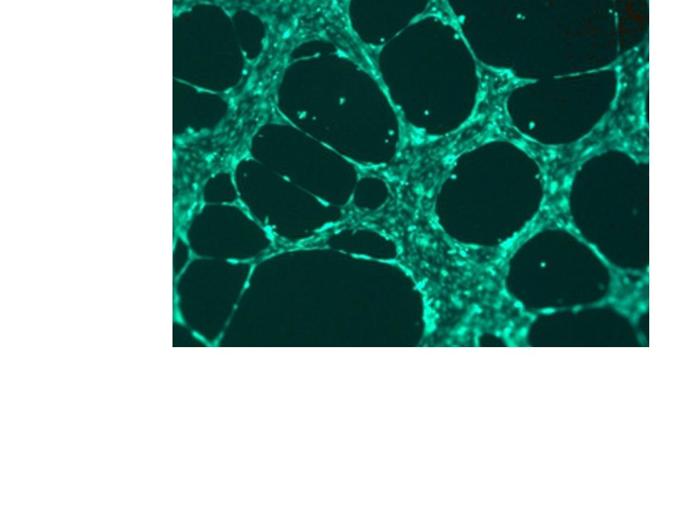
Application Note 19
8. Staining Protocol
Follow these steps:
1) Photograph the wells before staining. This gives you a comparison of the cell
pattern before and after staining.
2) Carefully discard the supernatant. Take care not to damage the gel or the cell
network.
3) Add 50 µl serum;free medium with diluted calcein (12.5 µl calcein stock
1 µg/µl) at a final concentration of 6.25 µg/ml (1:160).
4) Incubate in the dark for 30 minutes at room temperature.
5) Wash with PBS three times. Rinse the PBS slowly over the side of the upper
well. Don’t pipette it directly onto the cells. Remove it from the other side of
the well, so that it very gently rinses the cells.
6) Take fluorescence pictures at 485 nm/ 529 nm.
HUVEC network stained with calcein (6.25 µg/ml)
Application Note 19
© ibidi GmbH, Version 1.3, Helga Wagner, June 25th, 2012
Page 8 of 8

