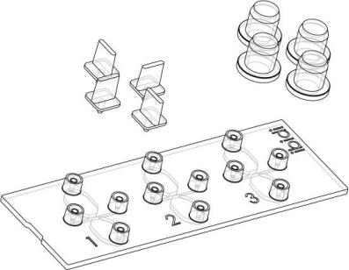
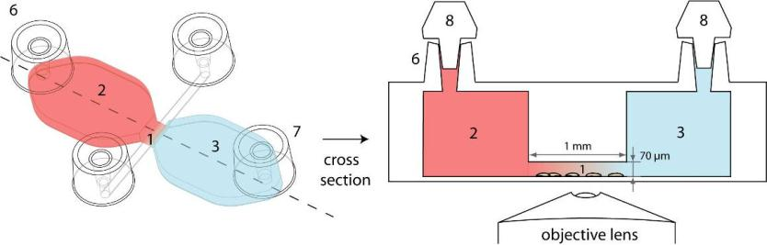
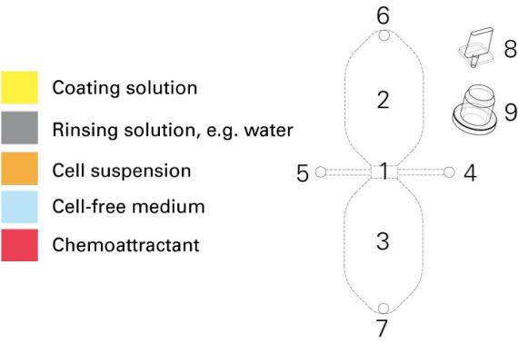


Application Note 14
2D Chemotaxis assay using μ-Slide Chemotaxis 2D
0. Important Notes
•
•
•
•
Read the related document “Important Notes” first.
Follow all steps in this protocol carefully.
Watch the handling movie on www.ibidi.com.
Start with free samples and the included food coloring.
1. General Information
The μ-Slide Chemotaxis 2D is a tool for observing
chemotactical responses of adherent migrating cells
in 2D over extended periods of time. The linear
concentration profile which is required for
chemotactical movement is generated by diffusion
and stable for at least 48 hours. Three chambers on
one slide allow parallel chemotaxis experiments. The
following protocol is adapted for adherent cells only.
Color code for liquids in
this Application Note:
Chamber configuration:
1 Observation area (2000x1000μm
2 Large reservoir (40μl)
2
)
3 Large reservoir (40μl)
4 Filling port with small side channel
5 Filling port with small side channel
6 Filling port
7 Filling port
8 Plugs
9 Cultivation caps
2. Principle
Two large volume reservoirs are connected by a thin slit. The reservoirs (2, 3) contain
different chemoattractant concentrations (indicated below by red and blue color). Inside the
connecting slit a linear and stable concentration profile is generated by diffusion.
Cross section indicating the place of
cells, chemoattractant, and gradient
Application Note 14
© ibidi GmbH, Version 2.6, Elias Horn, April 04
th
2012
Page 1 of 15

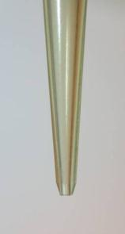
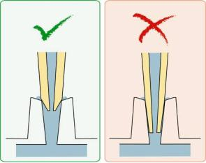

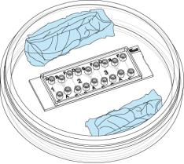
Application Note 14
3. Equipment
It is 100% necessary using the following equipment to conduct
chemotaxis experiments with the μ-Slide Chemotaxis 2D:
•
•
•
Adherent cells
Optimal conditions for cells (heated or incubated stage)
A humid chamber, such as a 10 cm Petri dish with wet
tissue (as shown on the right)
•
•
Inverted microscope (phase contrast, fluorescence, … )
Time lapse video equipment (CCD camera, video camera,
acquisition software)
Humid Chamber
With wet sterile tissue.
•
Use only correct 10 - 200 μl pipet tips. Others do not work.
o Greiner Bio-One 739261, 739280, 739290, 772288 or
related beveled Greiner tips.
o Axygen T-200-C, TR-222-C, TR-222-Y or related Axygen
beveled tips.
o STARLAB TipOne RPT S1161-1800 or related beveled
TipOne tips.
o Sorenson BioScience MulTi Fit Tip 10590, 15320,
15330.
•
•
Slant cosmetics tweezers, for plug handling
Optional: Motorized stage and autofocus (x,y,z) to observe
all 3 chambers in parallel.
Beveled Pipet Tip
See list for correct models
Correct tip
¾ Fits on top
Wrong tip
¾ Fits too tightly
¾ Closes completely ¾ Gets stuck
Slant Tweezers
For convenient plug handling
¾ Does not stuck
Application Note 14
© ibidi GmbH, Version 2.6, Elias Horn, April 04
th
2012
Page 2 of 15

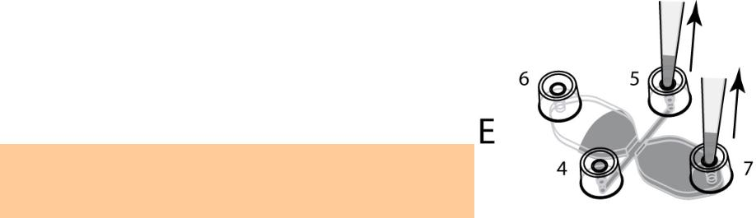
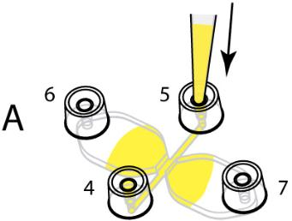
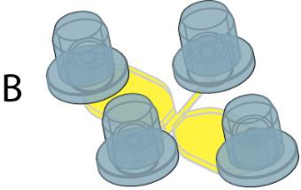
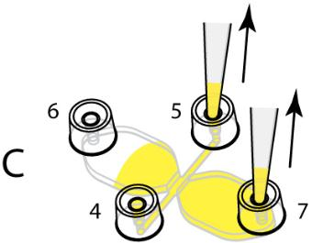
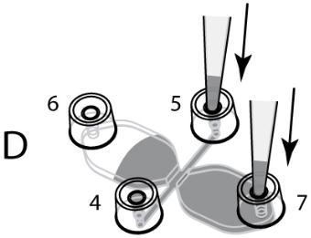
Application Note 14
4. Coating μ-Slide Chemotaxis
For direct use the tissue culture treated version μ-Slide
Chemotaxis 2D, ibiTreat (80306) or the precoated μ-Slide
Chemotaxis 2D, Collagen IV, sterile (80302) can be used.
Other coatings can be adapted by using the same
procedure described below. Work under sterile conditions.
a) Full Coating Protocol with Collagen IV
Please use the following protocol to coat the entire inside
of the chamber with Collagen IV.
2
(μ-Slide Chemotaxis 2D, ibiTreat, 0.8 μg/cm , 80 μl,
24 μg/ml, 2.4 cm
2
):
•
•
Dilute the Collagen IV (e.g. BD Cat.-Nr. 356233) to
a concentration of 24 μg/ml using 0.05 M HCl.
Inject 80 μl coating solution per chamber using the
filling port 5 (step A) until the chamber is
completely filled. Take care to fill all channels and
filling ports.
•
•
Leave at room temperature for at least 30 minutes.
Use the caps to decrease evaporation (step B).
Completely aspirate the solution using a cell
culture aspirator. Take care to aspirate from more
than one filling port to remove as much liquid as
possible (step C).
•
•
Wash with 80 μl ultra-pure water by injecting into
pipet ports 5 and 7 (step D). Please note that filling
the chamber with water or washing buffer is
difficult as long as it is not completely dried. Don’t
mind air bubbles at this point.
Aspirate exhaustively by using a cell culture
aspirator. Take care to aspirate from more than one
filling port to remove as much liquid as possible.
(step E)
•
•
Repeat until the entire inside is washed.
Let the chamber dry at room temperature
overnight under sterile conditions.
Please note that filling the chamber with cells or
washing buffer is difficult as long as it is not completely
dried.
Application Note 14
© ibidi GmbH, Version 2.6, Elias Horn, April 04
th
2012
Page 3 of 15

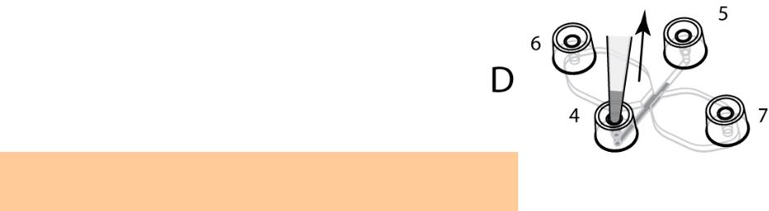
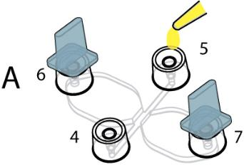
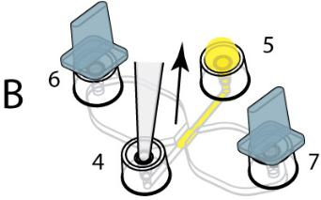
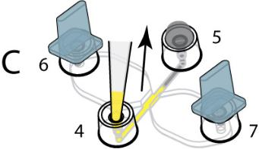
Application Note 14
b) Observation Area Coating Protocol with Collagen IV
(equal to ibidi Cat. No. 80302)
This protocol is used to coat the observation area only.
This will create a coating barrier so cells may not be
allowed to enter the large reservoirs. Only the observation
area and the side channels are coated with Collagen IV.
(μ-Slide Chemotaxis 2D, ibiTreat, 0.8 μg/cm , 6 μl,
2
60 μg/ml, 0.45 cm
2
)
•
•
•
•
Dilute the Collagen IV (e.g. BD Cat.-Nr. 356233) to
a concentration of 60 μg/ml using 0.05 M HCl.
Close filling ports 6 and 7 by plugs (not shown).
Handle plugs with appropriate blunt tweezers.
Use a 20 μl pipet (e.g. Gilson P-20) and apply 6 μl
coating solution onto filling port 5 (step A).
Use the same pipet settings and aspirate air from
the opposite filling port 4. (step B) Press the pipet
tip directly into filling port 4. The coating solution
on port 5 will be flushed inside filling the entire
channel homogeneously. Gently aspirate until the
solution reaches the pipet tip.
•
•
•
•
Remove the plugs and cover with lids. Leave at
room temperature for 60 minutes (not shown).
Gently close filling ports 6 and 7 by plugs (not
shown).
Put 10 μl ultra-pure water on top filling port 5
(step C). Don’t trap air bubbles.
Aspirate the same amount of liquid from cell inlet
adapter 5 as shown (step C). Repeat this step
twice.
•
•
Aspirate intensively all liquid from filling port 4 and
5 (step D).
Let the chamber dry at room temperature
overnight under sterile conditions.
After coating, the chamber needs to be completely dry.
Otherwise, the cell seeding protocol does not work correctly.
Application Note 14
© ibidi GmbH, Version 2.6, Elias Horn, April 04
th
2012
Page 4 of 15


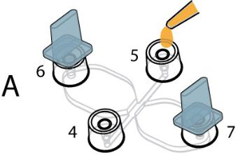
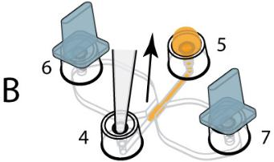
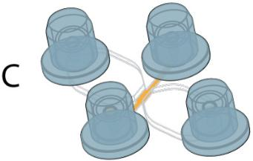
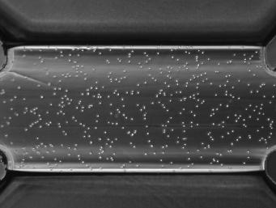
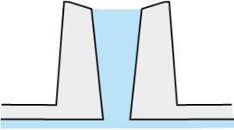
Application Note 14
5. Experiment
The day before seeding cells and
conducting
the
experiment,
it
is
necessary to place all cell media, the
μ-Slide, and plugs into the incubator
for gas equilibration. Media is put in a
slightly opened vial. This will prevent
the medium inside the slide and the
slide itself from emerging air bubbles
over the incubation time.
a) Seeding cells
•
•
Unpack the μ-Slide Chemotaxis and put into a
10 cm Petri dish with sterile, wet tissue around the
slide decreasing evaporation.
Prepare your cell suspension as usual. Use cell
concentration of ca. 3 x 10 cells/ml. High cell
6
concentrations are needed due to the small height
of the observation area.
•
•
Close filling ports 6 and 7 by plugs (not shown).
Handle plugs with appropriate blunt tweezers.
Use a 20 μl pipet (e.g. Gilson P-20) and apply 6 μl
cell suspension on top of filling port 5 (step A). Do
not inject directly.
•
Use the same pipet settings and aspirate air from
the opposite filling port 4. Press the pipet tip
directly into filling port 4. The cell suspension on
top of port 5 will be flushed inside filling the entire
channel homogeneously. Gently aspirate until the
cell suspension reaches the pipet tip. The
hydrophilic ibiTreat surface (TC-treated) supports
this step so different surface coatings can behave
differently.
•
Leave both filling ports (4 and 5) filled with cell
suspension. Level out the liquid heights in both
filling ports like this:
Do not overfill or underfill both filling ports to avoid
leakage. To achive this, the 6 μl seeding volume
may have to be adjusted.
•
•
•
•
Directly after cell seeding, gently remove the plugs
from filling port 6 and 7 by tweezers (not shown).
Cover all filling ports with cultivation caps (step C).
Do not use the plugs during cell attachment.
Control cell density and cell distribution by phase
contrast microscopy.
Incubate the slide inside a sterile and humid
atmosphere to minimize evaporation until cells
have attached. This should occur within 1-5 hours
depending on your cell type and surface. Make
sure evaporation is low by using a sterile 10 cm
Petri dish with extra wet tissue around the slide.
Observation area with recom-
mended cell density right after
seeding.
Application Note 14
© ibidi GmbH, Version 2.6, Elias Horn, April 04
th
2012
Page 5 of 15

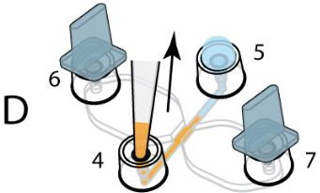
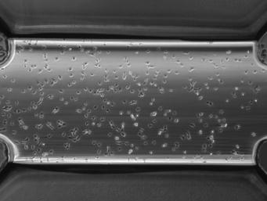
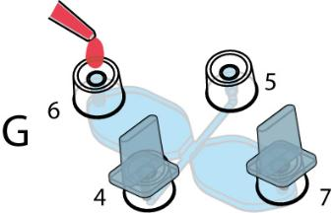
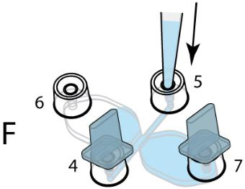
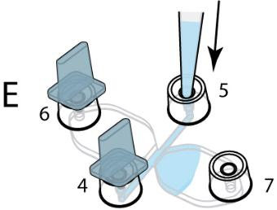
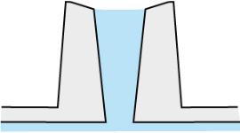
Application Note 14
b) Cell Attachment
•
Control cell attachment and morphology by phase
contrast microscopy. Control evaporation by
checking the amount of medium in filling port 4
and 5.
After cell attachment (1 – 5 h) remove non-adherent cells
and old medium:
•
•
•
•
•
Remove all cultivation caps from the filling ports
(not shown).
Gently close filling ports 6 and 7 by plugs (not
shown).
Fill 10 μl cell free medium onto filling port 5. Don’t
trap air bubbles (step D).
Aspirate the same amount of liquid from cell inlet
adapter 4 as shown (step D).
Cells in observation area after
attachment.
Repeat this step twice.
This washing protocol can also be used to pretreat the
cells before the chemotaxis experiment is started.
c) Filling the Reservoirs
•
Transfer the plug from filling port 7 to filling port 4.
(not shown)
•
Fill one reservoir by gently injecting 45 μl cell-free
medium into filling port 5 (step E). In this step it is
crucial not to detach cells. This can be achieved by
very gently pipetting. Slowly inject media until
filling port 7 is completely filled. (This is a very
critical step because cells might be flushed away
due to high flow rates. The longer the filling takes
the fewer your cells are stressed. Approx.
30 seconds per reservoir are fine.)
•
•
Transfer the plug from filling port 6 to filling port 7.
(not shown)
Fill the other reservoir by gently injecting 45 μl cell-
free medium into filling port 5 (step F). (Keep in
mind that all filling ports must be completely filled
but not overfilled, as shown.)
•
Now, the chamber is completely filled and cells
grow in the observation area only. Control your
cells under the phase contrast microscope.

d) Apply a Chemoattractant in one Reservoir
Make sure the two open filling ports 5 and 6 are
completely filled like this:
Application Note 14
© ibidi GmbH, Version 2.6, Elias Horn, April 04
th
2012
Page 6 of 15


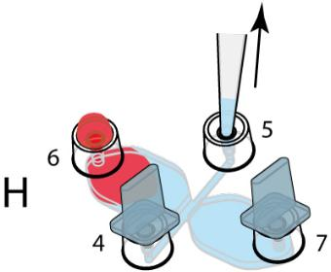
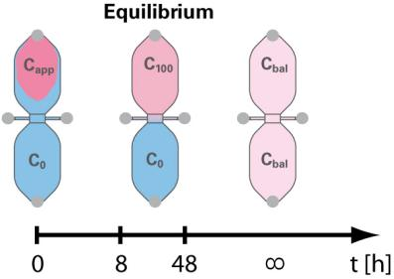
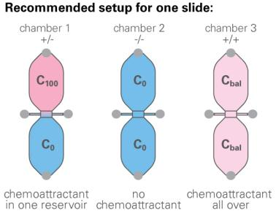
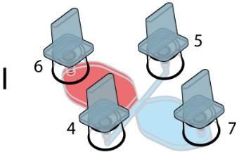
Application Note 14
•
Apply 18 μl of chemoattractant onto filling port 6 as
shown. Don’t trap air bubbles. Don’t inject the
chemoattractant directly (step G).
•
Aspirate the same amount of liquid (18 μl) from
filling port 5 (step H). This will flush the
chemoattractant into the large reservoir. Don’t
aspirate too fast as this might detach the cells.
Close both filling ports 5 and 6 with plugs. Start
with the non-attractant containing filling port 5
(step I). Don’t trap air bubbles.
After a short time the chemoattractant will diffuse
through the observation area and establish a linear
concentration profile over the cells. See § 10.
(fluorescence measurements) for details.
•
•
Please visit www.ibidi.com for movies on handling and
applications withμ-Slide Chemotaxis!
6. Chemoattractant Concentrations and Recommended Experimental Setups
a) Definition
For optimal results we recommend performing two control experiments by filling the chamber
completely with/without chemoattractant solution. That gives access to the question whether
a compound is influencing directed movement of cells (chemotaxis) and/or influencing random
migration (chemokinesis).
C100 Concentration in stable gradient equilibrium
(= max. concentration reaching the cells on one
edge of the observation area).
Capplied Concentration applied into the chamber with a
volume of 18 μl. Capplied = C100 x 2.5
1)
Cbalanced Balanced chemoattracntant concentration after
infinite time calculated with the total chamber
volume of 80 μl. Cbalanced = Capplied x 18 μl / 80 μl.
C0
Solution without (or low concentration) of
chemoattractant.
1)
In theory this value should be 40 μl / 18 μl = 2.22. Fluorescence measurements revealed
that a slightly higher concentration is needed due to the fact that in equilibrium the
chemotattractant containing reservoir already lost molecules for gradient establishment.
b) Calculation Example
Chemoattractant concentration profile over cells between
100 μg/ml (=C100) and 0 μg/ml (=C0) in equilibrium.
C100
= 100 μg/ml
Capplied = 100 μg/ml x 2.5 = 250 μg/ml
Cbalanced = 250 μg/ml x 18 μl / 80 μl = 56.25 μg/ml
C0
= 0 μg/ml
The used solutions are: Capplied for +/- experiment and C0
and Cbalanced for the two control experiments (-/- and +/+).
Preparation of C100 is not necessary.
Application Note 14
© ibidi GmbH, Version 2.6, Elias Horn, April 04
th
2012
Page 7 of 15

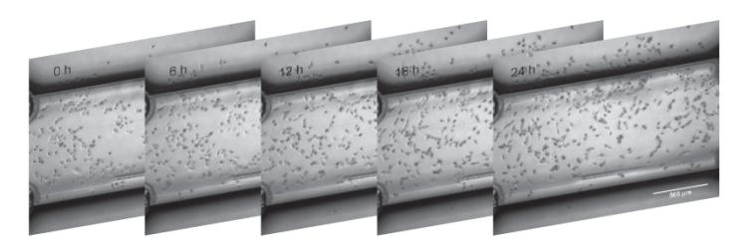
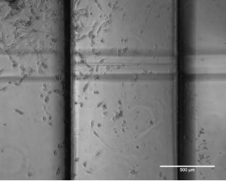
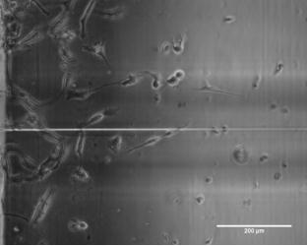
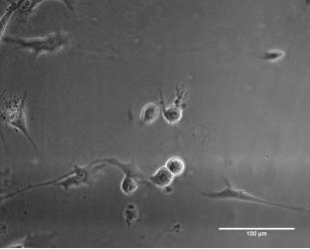
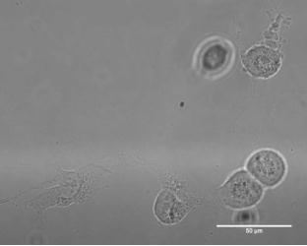
Application Note 14
7. Video Microscopy
Video microscopy is an absolutely necessary tool for ibidi’s μ-Slide Chemotaxis. Without, there
is no access and analysis of chemotaxis and migration effects.
•
Mount the μ-Slide Chemotaxis on the stage of your inverted microscope and observe
cell movement within the observation areas. Depending on the cells´ velocity one
frame per 1-10 minutes should be sufficient. For optimal migration data of slow
migrating cells we recommend starting the experiment immediately after filling in the
attractant and observe cell movement for 24 hours. After initial experiments this time
can be varied for efficient use of experimental time.
•
•
•
•
Depending on your cells´ requirements heating and incubation devices are necessary.
Please contact us for more details on incubation systems right on the microscope.
After mounting the slide on the microscope stage, wait 20 min for temperature
equilibration.
Start a time-lapse experiment with a 5x or 10x objective. Higher magnifications are
possible but for optimal migration data it is necessary to track at least 20 – 40 cells.
After the time-lapse export your images as uncompressed single page .tif files.
Depending on your focus of interest, choose a magnification:
4x/5x
10x
- lowest magnification
- lowest resolution
- medium magnification
- medium resolution
- maximum overview
- maximum number of cells
- medium number of cells
40x/100x
- highest magnification
- maximum resolution
- smallest number of cells
20x
- medium magnification
- medium resolution
- medium number of cells
Application Note 14
© ibidi GmbH, Version 2.6, Elias Horn, April 04
th
2012
Page 8 of 15

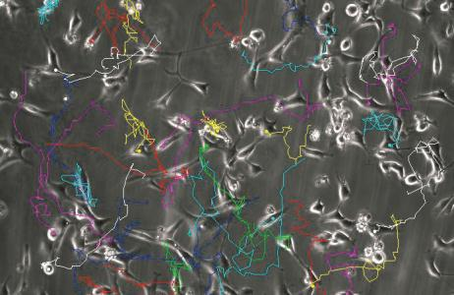
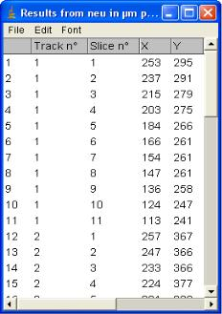
Application Note 14
8. Tracking Cells
After the experiment, it is necessary to track the cells with the appropriate software. We
recommend, for example, the ImageJ plugin, Manual Tracking. This plugin is able to quantify
the movement of objects between frames of a temporal stack.
•
•
ImageJ is available here: http://rsb.info.nih.gov/ij/
The Manual Tracking plug-in (including a PDF documentation) by Fabrice Cordelières,
Institut Curie, Orsay, France is available here:
http://rsbweb.nih.gov/ij/plugins/track/track.html
•
Download Manual_Tracking.class into the plugins folder of ImageJ on your computer
and restart ImageJ. Make sure you have administrator rights.
Quick guide for tracking with Manual Tracking:
1) Import a movie as single page .tif files, by using
„File/Import/Image_Sequence”.
2) Open plugin “Manual Tracking”.
3) Select “Add track”.
4) Follow the first cell, through all of the time points,
by clicking on the cell’s midpoint. After the first
click, the software creates the results table in an
extra window. This table is filled with the x/y data
of each cell, at each time point.
5) Save the data table after tracking is completed.
6) The data table contains all tracked cells (=tracks)
and time points (=slices) with (x,y) positions.
•
•
For tracking, we recommend printing out the first image of each image stack before
the movie is watched for the first time. At least 40 cells are uniformly marked in order
to 1) ensure homogeneity and 2) avoid tracking the same cell twice. At least 30 cells
in the observation field need to be tracked during the entire experiment. Some cells
will be lost through cell death, cell division, and cells leaving the observation field. We
do not recommend using such cells for data analysis.
You can also export “Overlay Dots & Lines” as a movie file (.avi).
Application Note 14
© ibidi GmbH, Version 2.6, Elias Horn, April 04
th
2012
Page 9 of 15

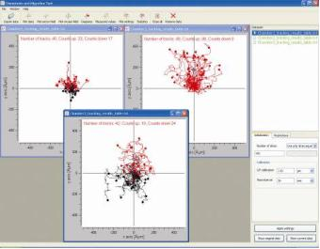
Application Note 14
9. Analyzing Chemotaxis
ibidi provides a free software tool for plotting and analyzing the tracked data. For a copy, go
to: http://www.ibidi.de/applications/ap_chemo.html
Here is a quick guide for data analysis:
1) Import the data table from “Manual Tracking” (tab-
separated .xls file)
2) Select the number of slices (=number of pictures
used for tracking). The number of slices can be
found in your original data table (“Show original
data”).
3) Calibrate the software by setting the x/y calibration
and the time interval. x/y calibration is the length of
one pixel in μm.
4) Press “Apply settings”, after changing values and
parameters.
5) Create trajectory plot, and then export as an image.
6) Export values of center of mass, FMI, and Rayleigh test.
7) Calculate a two-tailed unpaired Student t-test with independent variances for the
single values from 6). Compare the chemotaxis experiment +/- and the two control
experiments -/- and +/+ with each other to show statistical significance.
Example: Use the following command in Microsoft Excel.
=TTEST(A2:A4;B2:B4;2;3)
Here are some recommendations for presenting the results (in talks or publications):
•
•
•
•
•
Show the original movie (time lapse film of your cells).
Play the trajectory movie (time lapse film + overlaid cell trajectories).
Display the trajectory plot (graph).
Show the table or bar graph of center of mass, FMI, and Rayleigh test.
Include the results of the Student’s t-test.
Application Note 14
© ibidi GmbH, Version 2.6, Elias Horn, April 04
th
2012
Page 10 of 15

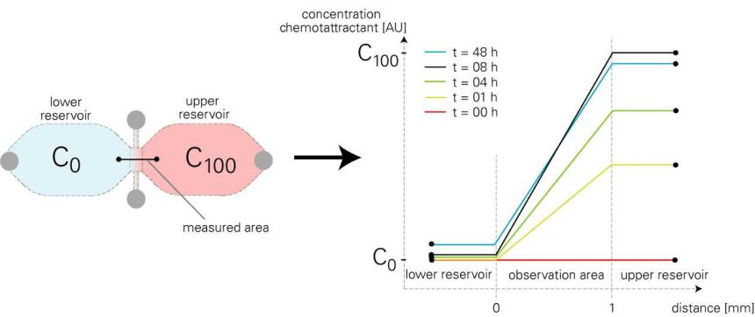
Application Note 14
10.Fluorescence Measurements
2
Fluorescence measurements with Alexa488 (diffusion coefficient D=316 μm /s) at room
temperature (22 °C) revealed the concentration profile as linear over the 1 mm observation
area. The profile is established after 1-8 h. After that it reaches steady state (equilibrium).
Please note that there is no gradient inside the reservoirs. The profile is maintained linear for
over 48 h. After that it slowly flattens due to the concentration equilibration between the
reservoirs.
11.Different Chemoattractants and Time Dependencies
If you use a chemoattractant with different molecular weight Mmolecule
(and diffusion constant
Dmolecule), different temperatures T , and solutions with different dynamic viscosities η solution
,
diffusion will be faster or slower. The following example (Alexa488 in water vs. VEGF in
endothelial cell growth medium) shows how to compare our fluorescence measurements
with different chemoattractants in different solutions.
Parameters:
ηAlexa488 (22°C) = 1·10 -3
kg/s·m
ηEC growth medium (37°C) = 0.75·10 -3
kg/s·m
T1 =37°C=310K
T2 =22°C=295K
To simplify matters the diffusing molecules are assumed to be globated. The hydrodynamic
radius is therefore dependent on the molecular weight only:
R h ≈ 3 M molecule
with:
MVEGF =45,000Da
MAlexa488=570Da
Application Note 14
© ibidi GmbH, Version 2.6, Elias Horn, April 04
th
2012
Page 11 of 15

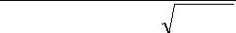
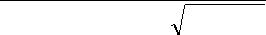
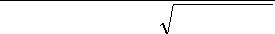
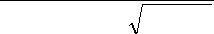
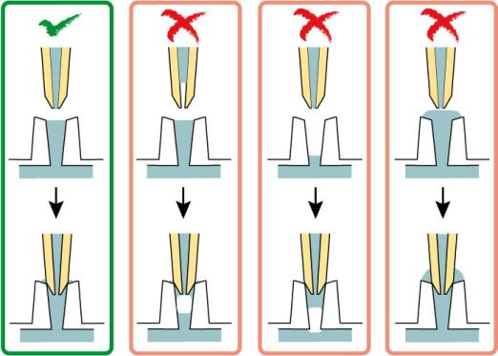
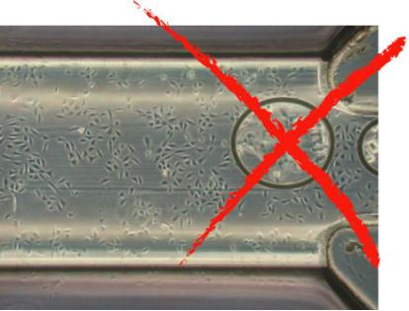

Application Note 14
Comparison:
T1
310K
k BT1
T1
ηECgrowthmedium(37°C) 3 MVEGF = 0.75·10-3 kg/s·m3 45,000Da
DVEGF
DAlexa488
= 6πη1 R
η1 R h1
T2
h1
=
=
k T
T2
295K
B
2
6πη2 R h2
η2 R h2
ηAlexa488solution (22°C) 3 MAlexa488
1·10-3 kg/s·m3 570 Da
DVEGF
= 0.33
DAlexa488
By using VEGF in endothelial growth medium as chemoattractant at 37°C the diffusion is
slower with factor 3. The concentration profile is build up slower with that factor. The diffusion
of different chemoattractants can be calculated identical.
12.Tips, Tricks and Troubleshooting
a) Avoiding Air Bubbles
Air bubbles are 1) emerging over time due to not equilibrated media and slides or 2) injected
or brought into the chamber by the user. Both types will disturb the diffusion driven
concentration gradient by convection and must be avoided.
1) Emerging air bubbles over time can be avoided by equilibrating all media and
equipment inside the incubator overnight. Media are put into a slightly opened vial.
Slides and plugs can be left in the sterile packaging.
2) The second type of bubbles can be avoided by correct handling. Please avoid unfilled
filling ports and trapped air bubbles inside the pipet tip! Keep in mind that an air
bubble might be trapped when closing an empty adapter by a plug. Always make sure
the filling ports are completely filled but not overfilled.
Avoid unfilled filling ports and air
bubbles inside the pipet tip!
Application Note 14
© ibidi GmbH, Version 2.6, Elias Horn, April 04
th
2012
Page 12 of 15

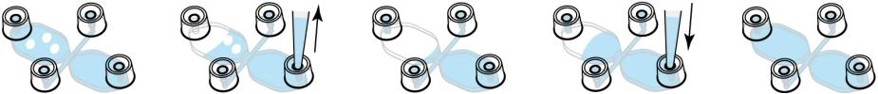
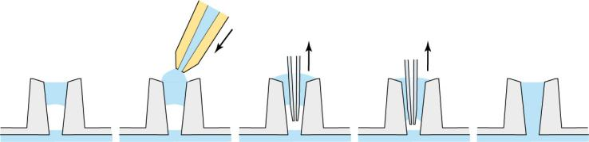
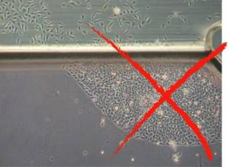
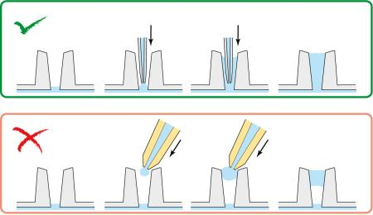
Application Note 14
Accidentally empty filling ports can be refilled
by a 10 μl pipet with a very thin pipet tip.
Never use the recommended yellow pipet
tips (see § 3) for this. An air bubble might be
trapped.
b) Removing Air Bubbles
Air bubbles in channels and reservoirs can often be removed by the following procedure.
Gently empty the reservoir containing the air bubble from the opposite side. Aspirate until the
atmospheric air reaches the air bubble. After the air bubble bursts re-inject the aspirated
liquid. Always incline the slide so liquid is beneath the air phase.
Trapped air bubbles in filling ports can be removed by aspiration. Puncture them and aspirate
with a 10 μl pipet with a very thin pipet tip. To make sure there is enough liquid for a correctly
filled filling port, add a drop of liquid onto the trapped air bubble before the procedure.
c) Inhomogeneous Cell Distribution
Inhomogeneous cell distribution, especially high cell densities
close to the observation area, negatively overlays directed
migration and must be avoided. Carefully conduct all steps
following the protocol at § 5a to avoid spilling cell suspension
into the reservoirs. Never inject cell suspension directly into
filling ports.
Application Note 14
© ibidi GmbH, Version 2.6, Elias Horn, April 04
th
2012
Page 13 of 15

Application Note 14
d) Chamber Fills not Properly
There are some general tips and tricks for filling the chamber:
¾ During filling by injection of liquid incline the slide in a way that liquid is beneath air.
Doing this air can escape trough the filling ports.
¾ Always use chambers that are completely dry.
Especially after coating the chambers need to be completely dry. Small liquid remains
might hinder proper handling.
¾ Use a pipet that is serviced routinely.
After some years of use pipets can loose pressure during pipetting. In normal work
they might perform great but there can be problems when used with μ-Slide
Chemotaxis.
e) Cells do not Attach Properly
The chamber’s geometry is very special. Especially the cell seeding step is critical because
the volume is very low. Most problems with cell attachment can be avoided by checking the
following questions:
¾ Are the cells seeded in optimal growth medium?
Adherent cells will not attach properly when they are seeded in starvation medium.
Use normal growth medium with all necessary supplements like serum.
¾ Is the slide put into an extra humid chamber?
Evaporation is one of the most crucial issues during cell attachment. Make sure to
provide a maximum of humidity during cell attachment.
¾ Is the incubator frequently opened during cell attachment?
Frequent door openings must be avoided because this lowers humidity inside the
incubator drastically for a short time. A cell culture incubator that is not used by others
during cell attachment is perfect.
¾ Is the surface/coating suitable for the cell type you use?
Use a surface coating which is known to provide cell attachment for your cell type.
f) Cells Are Flushed Away When Filling the Chamber
Most problems can be solved by checking the following points:
¾ Use adherent cells only.
¾ Fill the chamber with cell-free medium very carefully.
Depending on the filling speed there can be enormous shear forces during this step.
Control your cells under the phase contrast microscope after each pipetting step to
check during which step the problem occurs.
¾ Change the surface.
Since evaporation is critical during cell attachment it is favorable using a precoated
surface. Coatings decrease attachment time because cells do not have to produce
their own extracellular matrix (ECM).
¾ Use μ-Slide Chemotaxis 3D
Our μ-Slide Chemotaxis 3D can also be used to conduct 2D experiments without the
use of gel. For this method, cells need to be slightly adherent to the surface of the
observation area only. More details can be found in our Application Note 17 in the
section 2D assay with slightly adherent cells.
g) Scratches Inside the Observation Area
Scratches on the bottom of the slide can be due to putting the slide directly on a flat metal
surface as the work bench. Avoid draggling the slide on the bench. Always use the slide
directly inside a 10 cm Petri dish.
Application Note 14
© ibidi GmbH, Version 2.6, Elias Horn, April 04
th
2012
Page 14 of 15

Application Note 14
Some scratches are part of the chamber itself. Unfortunately, those are normal in this slide
and unavoidable. These scratches are on the ceiling of the channel, not on the bottom, where
the cells are. Depending on the objective lens used (depth of focus) they are more or less
visible.
h) Temperature Instabilities
Major changes in temperature during the experiment may cause convection thus disturbing
the diffusion driven gradient. Keep the temperature as stable as possible.
i) Focus not Stable
Especially during time lapse experiments focus drift is an annoying effect. Focus stability is
mainly influenced by mechanical changes and temperature instabilities. Follow these
recommendations to keep your cells in focus:
¾ Switch on all components (heating, gas incubation, computer, other equipment) at
least 60 min before starting the time-lapse recording.
¾ After you put the μ-Slide onto the microscope wait 20 min before starting a time lapse
experiment to achieve temperature (and immersion oil) equilibration.
¾ Keep the room temperature as stable as possible. Air conditioning should either be
working continuously or should be switched off.
¾ Do not change temperature during experiments. Avoid door/window openings as this
could change temperature rapidly.
¾ Eliminate all sources of mechanical vibrations. Use a damped table for your
microscope.
¾ Use an autofocus system.
Please contact info@ibidi.com for more information.
Application Note 14
© ibidi GmbH, Version 2.6, Elias Horn, April 04
th
2012
Page 15 of 15

