
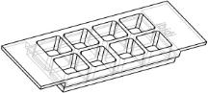
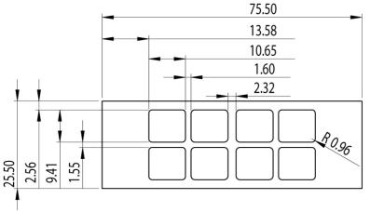
Instructions
sticky–Slide8well
www.ibidi.com
The sticky–Slide family allows you to perform cell culture experiments with custom–
speciﬁcbottommaterialslikeplasticsheets,glassslides,spottedcoverslips,printedcir-
cuitboards,etc. Theselfadhesive(”sticky”)undersideofthebottomlessblankslideis
easilyadaptedtoyourspeciﬁcsubstratebypressingonbyhand.
sticky–Slide8wellprovidesacommonopenwellformatwhichisbestsuitedformaxi-
mumsampleaccessinawidevarietyofexperimentalapplications.
Material
• Optionally for channel sticky–Slides, place your
sampleintothechannel.
The slide material of sticky–Slides is identical to com-
monµ–Slides(uncoated). TheSlidesarenotautoclavable
sincetheyaretemperaturestableupto60°C/140°Fonly.
All sticky–Slides are delivered sterile and single packed.
Pleasekeepinmindthatsterilityislostwhennon–sterile
substratesareused.
Thestickybottomitselfisa50µmbiocompatibledouble–
facedadhesivetape. Thetapeiscoveredbyaprotection
ﬁlmwhichhastoberemovedbeforeusage.
• Mountbottomandsticky–Slidewithsomepressure.
Presswelluntilthebottomissealed.
• Incubateat20-40°Cforbestresults.
• Conductyourexperiment.
The adhesive strength strongly depends on temperature
andtime. Bestresultsareachievedbystoringtheassem-
bledSlidesovernightat20-40°C.Anyhow, sticky–Slides
arenotleakyimmediatelyafterassembling.
sticky–Slidescan beremovedfrom thesubstrateby dip-
pingthemintoAcetoneovernightinanappropriateglass
container(e.g.abeaker).PleasekeepinmindthatAcetone
mightbeharmfultoyourusedsubstrate. Onceremoved
sticky–Slidescannotbereused.
Geometry
All technical details beside bottom material are identical
toµ–Slide8well. TheSlidesprovidestandardslidefor-
mataccordingtoISO8037/1.
Geometryofsticky–Slide8well
Surfacecompatibility
Numberofwells
8
Dimensionmm of wells (w×l×h) in 9.4×10.7×6.8
sticky–Slidesarecompatiblewithallﬂat,clean,dust–free,
fat–freesurfaceslikeglass,plastic,metal,siliciumorelec-
trodestructures. sticky–Slidescanbeassembledwithwet
surfaces(protein–free,aqueoussolutionslikewaterorPBS
buffer). Dusty or fatty surfaces like wax foils or similar
surfacesarenotcompatible. Pleasetestyourspeciﬁcsur-
faceinyourlabwithfreesamplesfrom
Recommendedvolumeperwell
Totalheightwithlid
Growthareaperwell
Bottom
300µl
8mm
1.0cm2
none
Bestresultsareachievedwhenﬂexiblesubstrateslikeplas-
ticsheetsorcoverslipsareused.Rigidglassslidesormetal
surfacesarealsopossibletousebutneedmorepressureto
seal.
Seedingcells
• Trypsinizeandcountcellsasusual. Dilutethecell
suspensiontothedesiredconcentration.Depending
onyourcelltype,applicationofa4–9×104cells/ml
suspensionshouldresultinaconﬂuentlayerwithin
2–3days.
HandlingandAssembling
• Apply 300 µl cell suspension into each well of the
Slide.Avoidshakingasthiswillresultininhomoge-
neousdistributionofthecells.
• Prepareyoursampleand/orbottommaterial.
• Removetheprotectionﬁlmbyusingsteriletweezers.
sticky–Slide8well
Page1
Version2012-05-04

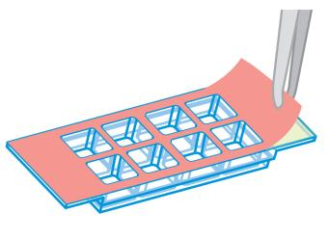
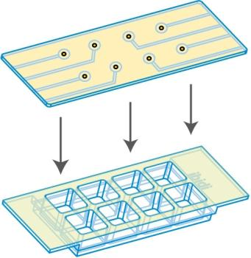
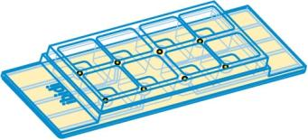
Instructions
sticky–Slide8well
www.ibidi.com
• Coverreservoirswiththesuppliedlid. Incubateat
37°Cand5%CO2asusual.
Undemanding cells can be left in their seeding medium
foruptothreedaysandgrowtoconﬂuencethere. How-
ever, best results might be achieved when the medium
is changed every 1–2 days. Carefully aspirate the old
mediumandreplaceitby300µl/wellfreshmedium.
ImmersionOil
Immersion oil compatibility depends on the used sub-
strate.
Applications
sticky–Slide 8 well provides a common open well for-
matwhichisbestsuitedformaximumsampleaccess,e.g.
whencellshavetobeseededontoatitaniumimplantma-
terial.
SolventsforFixation,StainingandOtherPur-
poses
Thestickybottommaterialandtheslidematerialarecom-
patibletoMethanol, acids, alkalis, PFA,DMSO,andsili-
coneoil.Pleasekeepinmindthatthesesubstancesmaybe
harmfultotheusedsubstrate. Acetoneisnotcompatible
withthestickymaterialsoitcanbeusedtodetachslide
andsubstrateafteruse.
sticky–Slide8well
Page2
Version2012-05-04

Instructions
sticky–Slide8well
www.ibidi.com
sticky–Slidefamily
Thesticky–Slidetechnologyisavailablewithdifferentslideformats.Pleaseseetablebelowforchoosingyoursticky–Slide.
Productname
Orderingnumber Basedonµ–Slideformat
Characteristics
sticky–Slide8well
sticky–SlideVI0.4
80828
80328
80608
81128
80168
80178
80188
80198
10812
µ–Slide8well
µ–SlideVI0.4
8openwells(volume300µl)
channelslide(height400µm)
forchemotaxisexperiments
channelslide(height100µm)
channelslide(height200µm)
channelslide(height400µm)
channelslide(height600µm)
channelslide(height800µm)
25.0mm×75.0mm,No.1.5
(selectedquality,170µm±10µm)
sticky–SlideChemotaxis3D
sticky–SlideI0.1Luer
sticky–SlideI0.2Luer
sticky–SlideI0.4Luer
sticky–SlideI0.6Luer
sticky–SlideI0.8Luer
µ–SlideChemotaxis3D
µ–SlideI0.1Luer
µ–SlideI0.2Luer
µ–SlideI0.4Luer
µ–SlideI0.6Luer
µ–SlideI0.8Luer
glasscoverslips,unsterile
Forresearchuseonly!
FurthertechnicalspeciﬁcationscanbefoundatForquestionsandsuggestionspleasecontactusbye–mailinfo@ibidi.de
orbytelephone+49(0)89/52046170.AllproductsaredevelopedandproducedinGermany.
©ibidiGmbH,AmKlopferspitz19,82152Martinsried,Germany.
sticky–Slide8well
Page3
Version2012-05-04

