
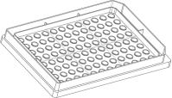

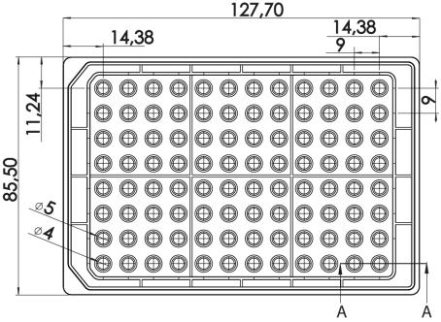
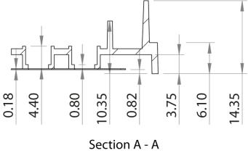
Instructions
µ–PlateAngiogenesis96well
Theibidiproductfamilyiscomprisedofavarietyofµ–Slidesandµ–Dishes,whichhaveallbeen
designedforhigh–endmicroscopicanalysisofﬁxedorlivingcells. Thehighopticalqualityof
thematerialissimilartothatofglass,soyoucanperformallkindsofﬂuorescenceexperiments
withuncompromisedresolutionandchoiceofwavelength.
Theµ–PlateAngiogenesis96wellallowsyoutoperformtubeformationassaysongel,combined
withhighresolutionmicroscopyinastandardmulti–wellformat.
Material
SingleWellParameters
Volumeinnerwell
10µl
ibidiµ–Slides,µ–Dishes,andµ–Platesaremadeofaplas-
tic that has the highest optical quality. The bottom ma-
terial exhibits extremely low birefringence and autoﬂuo-
rescence, similar to that of glass. Also, it is not possible
todetachthebottomfromtheupperpart. Theµ–Slides,
µ–Dishes, and µ–Plates are not autoclavable, since they
areonlytemperature–stableupto80°C/175°F.Pleasenote
that gas exchange between the medium and incubator’s
atmosphere occurs partially through the polymer cover-
slip,whichshouldnotbecovered.
Diameterinnerwell
Depthinnerwell
4mm
0.8mm
70µl
Volumeupperwell
Diameterupperwell
Growthareainnerwell
Coatingareausing10µl
5mm
0.125cm2
0.23cm2
AccuracyoftheBottom
Innerwellﬂatness
Wholeplateﬂatness
Bottom
±5µm
OpticalPropertiesibidiStandardBottom
±25µm
RefractiveindexnD(589nm)
Abbenumber
1.52
ibidiStandardBottom
56
Theµ–PlateAngiogenesis96wellmeetsallimportantval-
uesoftheANSI/SBSStandards(1-2004,2-2004,3-2004and
4-2004).
Thickness
No.1.5(180µm)
Material
microscopyplastic/
polymercoverslip
Please note! The ibidi standard bottom is compatible
withcertaintypesofimmersionoilonly. Alistofsuit-
ableoilscanbefoundonpage3.
Geometry
The µ–Plate Angiogenesis 96well provides standard ge-
ometryandnumbering(A-H,1-12). Thebottomoftheµ–
PlateAngiogenesis96wellprovidesahighaccuracy.
Dimensionsoftheµ–PlateAngiogenesis96wellinmm
Length
127.7
85.5
16.5
14.4
9.0
±0.2
±0.2
±0.4
±0.4
±0.1
Width
Heightwithlid
Heightwithoutlid
Welltowelldistance
µ–PlateAngiogenesis96well
Page1
Version2014-08-25

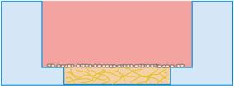


Instructions
µ–PlateAngiogenesis96well
ShippingandStorage
Non-gelbasedcoatingsarealsopossible. Pleaseuse10µl
coatingsolutionandcalculatewithanareatobecoatedof
0.23cm2 perwell. Furtherinformationaboutcoatingsis
The µ–Slides, µ–Dishes and µ–Plates are sterilized and
weldedinagas-permeablepackaging.Theshelflifeunder
proper storage conditions (in a dry place, no direct sun-
light)islistedinthefollowingtable.
providedin
SeedingCells
Conditions
Shippingconditions
Storageconditions
Ambient
In a tube formation assay cells are seeded on top of the
polymerizedgelmatrix:
RT(15-25°C)
ShelfLifeofDifferentSurfaces
ibiTreat,glassbottom,ESS
36months
18months
4months
Collagen,Poly-Lysine
Fibronectin
1. Trypsinizeandcountcellsasusual. Dilutethecell
suspensiontothedesiredconcentration.Depending
onyourcelltype,werecommend1–3×105cells/ml.
Surface
2. Apply 70µl of the cell suspension into the upper
well.Donottouchthegelmatrixwiththepipettip.
Theµ–PlateAngiogenesis96wellisavailablewithibiTreat
surface. TheibiTreatsurfaceisaphysicaltreatmentand
optimizedforadhesionofmostcelltypes.Manycelllines
aswellasprimarycellsweretestedforgoodcellgrowth.
3. Cover the µ–Plate Angiogenesis 96well with the
suppliedlid.Incubateat37°Cand5%CO2asusual.
4. Conductyourexperiment.
Aspeciﬁccoatingoftheµ–PlateAngiogenesis96wellcan
bedoneyourselffollowingtheprocedureinsection”Coat-
ing”.
5. Depending on the cell type, medium exchange is
necessaryevery1–2days. Carefullyaspiratetheold
mediumandreplaceitby70µlfreshmedium.
Foradetailedprotocolpleasereferto
and

RemovetheProtectionFilmbeforeUsage
Thebottomoftheµ–PlateAngiogenesis96welliscovered
withaﬁlmtoprotecttheopticalqualityoftheplasticsur-
face.Pleasepullofftheprotectionﬁlmbeforeusage!
Furtherinformationabouttheoptimizationofexperimen-
talparametersanddataanalysisisprovidedin

Coating
Tip:
Airbubblesinthegelcanbereducedbyequilibrating
theµ–PlateAngiogenesis96wellbeforeusageinside
theincubatorovernight.
Intubeformationassaystheµ–PlateAngiogenesis96well
iscoatedwitha0.8mmthicklayerofgelmatrix.
1. Prepare your gel matrix according to the manufac-
turer’sprotocolorreference.
2. Fill the inner well with 10 µl liquid gel. Avoid air
bubbles.
Tip:
Forlessevaporationthereservoirsattheedgescanbe
ﬁlled with sterile water or agarose. Add agarose to
water or buffer solution (e.g. 0.1 g to 10 ml water).
Melt agarose solution using a microwave or boiling
waterbathandallowthesolutiontocoolto∼50°C.
3. Letthegelpolymerizeunderappropriateconditions.
4. Useassoonaspossible.
5. Ifstorageisneededﬁllsterilewaterinthereservoirs
attheedgesoftheplate.
µ–PlateAngiogenesis96well
Page2
Version2014-08-25


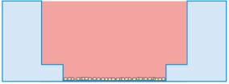
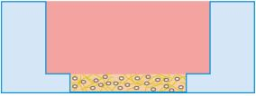
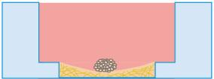
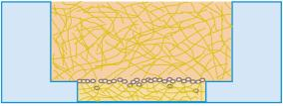
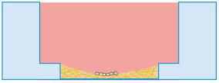
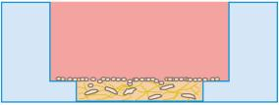
Instructions
µ–PlateAngiogenesis96well
Tip:
Incasebentgelsurfacesarecreated, increaseorde-
creasetheamountofgelused,untilyougetﬂatand
evengels.
• Filltheinnerwellwithalowvolumeofthegelma-
trix,e.g. 8µl. Seedcellsontopofthepolymerized
gel. Ifnecessarygentlyshaketheslidetomakethe
cellsslideintothemiddleofthewell.
Tip:
Youcanstacktheµ–PlatesAngiogenesistosavespace
inyouincubator. Thiswillnotaffectcellgrowth. We
recommendmakingbatcheswithupto6plates,due
tostabilityreasons.
• Filltheinnerwellwithﬁbroblastssuspendedinside
agelmatrix.Seedcellsontopofthepolymerizedgel.
Overlaythecelllayerwithmediumandincubatefor
invasionofthecellsintothegelmatrix.
ExperimentalSetups
Alternatively, the µ–Plate Angiogenesis 96well can be
usedforthefollowingassays:
• Culturecellswithoutagelmatrixdirectlyinthemi-
norwells.
PreparationforCellMicroscopy
Whengelmatricesareusedtheopticalqualityandtheuse
ofhighmagniﬁcationobjectivelensesmightberestricted.
Withoutanygelcellscanbeobservedliveorﬁxeddirectly
inthewellsonaninvertedmicroscope. Youcanuseany
ﬁxativeofyourchoice. Theplasticmaterialiscompatible
withavarietyofchemicals,e.g.AcetoneorMethanol.Fur-
ther speciﬁcations can be found at Due
to the thin bottom of only 180 µm, high resolution mi-
croscopyispossible.
• Filltheinnerwellwithcellssuspendedinsideagel
matrix. Aftergelpolymerization,add70µlcell–free
mediumtoﬁlltheupperwell.
ImmersionOil
When using oil immersion objectives, use only the im-
mersion oils speciﬁed in the table. The use of a non–
recommendedoilcouldleadtothedamageoftheplastic
materialandtheobjective.
• Fill the inner well with a gel matrix and culture
piecesoftissueorcellspheroidsonit.
Company
Product
OrderingNumber
ibidi
Zeiss
Zeiss
Leica
ImmersionOil
(ibidi)50101
Immersol518F
ImmersolW2010
Immersionliquid
(Zeiss)444960
(Zeiss)444969
(Leica)11513859
• SandwichCellCulture:Filltheinnerwellwithagel
matrix.Seedcellsontopofthepolymerizedgeland
imbedthecellswith70µlgelintheupperwell.
µ–PlateAngiogenesis96well
Page3
Version2014-08-25

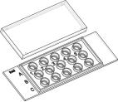
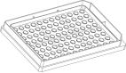
Instructions
µ–PlateAngiogenesis96well
µ–PlateAngiogenesis96wellFamily
Theµ–PlateAngiogenesis96wellfamilyisavailablewithdifferentsurfacesandformats.Seetablebelowforchoosingyour
µ–Slideandµ–PlateAngiogenesis,respectively.
µ–SlideAngiogenesis
Cat.No.
Description
81506
81501
81531
µ–SlideAngiogenesisibiTreat:#1.5polymercoverslip,tissueculturetreated,sterilized
µ–SlideAngiogenesisuncoated:#1.5polymercoverslip,hydrophobic,sterilized
µ–SlideAngiogenesisMicrodissection:PEN-membrane∗ ,sterilized
∗ThePENfoildoesnotﬁttostandardcoverslipthickness.
µ–PlateAngiogenesis96well
Cat.No.
Description
89646
µ–PlateAngiogenesis96wellibiTreat: #1.5polymercoverslip, tissueculturetreated,
sterilized
References
P.S.Chen,Y.W.Shih,H.C.Huang,andH.W.Cheng. Diosgenin,aSteroidalSaponin,InhibitsMigrationandInvasion
ofHumanProstateCancerPC-3CellsbyReducingMatrixMetalloproteinasesExpression. PLoSONE,2011. doi:10.1371/
journal.pone.0020164.
J.Searle,M.Mockel,S.Gwosc,S.A.Datwyler,F.Qadri,G.I.Albert,F.Holert,A.Isbruch,L.Klug,andD.N.Muller.Heparin
StronglyInducesSolublefms-LikeTyrosineKinase1ReleaseInVivoandInVitro. Arteriosclerosis,Thrombosis,andVascular
Biology,2011.doi:10.1161ATVBAHA111.237784.
E. Vo, D. Hanjaya-Putra, Y. Zha, S. Kusuma, and S. Gerecht. Smooth-Muscle-Like Cells Derived from Human Em-
bryonic Stem Cells Support and Augment Cord-Like Structures In Vitro. Stem Cell Reviews and Reports , 2010.
doi:
10.1007/s12015-010-9144-3.
Forresearchuseonly!
FurthertechnicalspeciﬁcationscanbefoundatForquestionsandsuggestionspleasecontactusbye-mailinfo@ibidi.de
orbytelephone+49(0)89/52046170.AllproductsaredevelopedandproducedinGermany.
©ibidiGmbH,AmKlopferspitz19,82152Martinsried,Germany.
µ–PlateAngiogenesis96well
Page4
Version2014-08-25

