

Important Handling Information
for the µ-Slide Chemotaxis
2D
READ THIS BEFORE USE
Read this information sheet in its entirety BEFORE working with the µ-Slide
2D
Chemotaxis . The following points are essential for successful handling.
1. Documents
•

• Read Application Note 14
• Watch the handling video:
2. Pipet Tips
Due to the filling ports’ design, this slide is only compatible with the following pipet tips. Using
other tips will skew your results.
• Greiner Bio-One 739621, 739280, 739290, 772288
• Axygen T-200-C, TR-222-C, TR-222-Y
• Starlab TipOne RPT S1161-1800
• Sorenson BioScience MulTi Fit Tip 10590, 15320, 15330
3. Degassing Slides
Place slides and medium in an incubator before use to ensure that all gasses have been removed. Gas
bubbles will ruin your assay. You may leave the slide enclosed in the sterile package when doing this.
4. Humidity and Evaporation
Evaporation can occur due to the small volume of the slides. It is imperative to maintain high
humidity during the attachment of your cells in order to avoid evaporation.
www.
.com


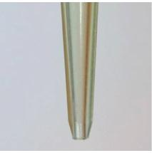
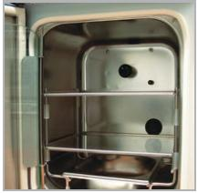
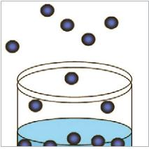


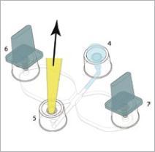
IMPORTANT HANDLING INFORMATION
Read this information sheet carefully BEFORE using the ibidi µ-Slide Chemotaxis
2D
General
Register for a 2 day
Laboratory Course at ibidi
Munich / Germany:
• Read and directly follow instructions provided in Application Note 14.
• Watch the handling video on www.ibidi.com.
http://ibidi.com/events/
practical-courses
• The µ-Slide Chemotaxis
2D
is designed for adherent cells only.
• The assay is not an endpoint measurement, thus cell migration
and chemotaxis must be followed by video microscopy. Go to
www.ibidi.com to download our Chemotaxis and Migration Tool.
• Contact us at info@ibidi.com for support, questions, or comments.
Pipet Tips and Pipets
• You must use the recommended 20-200 µl beveled pipet tips
when preparing the slide.
• Make sure that your pipet is working properly and maintain
constant pressure during operation. Use a pipet which is serviced
and calibrated routinely.
• Make sure to fill the pipet adapters on the slide fully; avoid air
bubbles inside the pipet tip.
Gas Equilibration
• Incubate all media, slides and slide caps/plugs overnight for gas
and temperature equilibration.
• Loosen screw top on media container to ensure gas escape. Do
not remove completely in order to maintain sterility.
• The µ-Slide Chemotaxis
2D
and slide plugs/caps come in a sterile
package. This can be put directly into your incubator without
opening to maintain sterility.
Evaporation
• To avoid evaporation during cell attachment, place the µ-Slide
2D
into a 10 cm Petri Dish and surround completely by
wet tissue. Use sterile tissue and water.
Chemotaxis
• Do not open your incubator on a frequent basis during cell attachment.
Handling
• Use the provided practice kit with colored water to practice pipetting.
• Keep in mind that air has to escape when filling a chamber. Always
inject into a pipet adapter or channel which is already filled.
• If coating the slides yourself, the chambers must be allowed to
dry completely.
ibidi GmbH
Tel.:
Fax:
E-Mail: info@ibidi.de
+49 89 / 520 46 17 - 0
+49 89 / 520 46 17 - 59
For more information on our
Am Klopferspitz 19
82152 Planegg/Martinsried
Germany
products, and to download our
full catalog, please visit us at:
www.ibidi.com
© ibidi GmbH, V 2.0, 2015 / 08

