
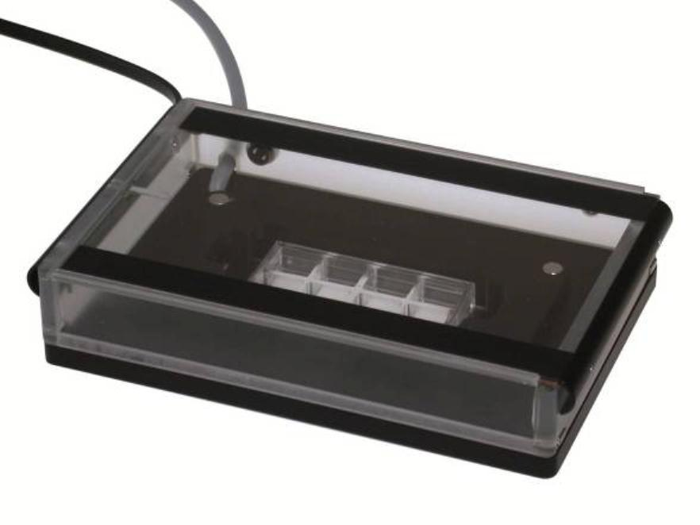
Instruction Manual
Heated Lid & Heated Plate
for 1 Chamber
(Universal Fit)


Heated Lid & Heated Plate for 1 Chamber (Universal Fit), Instruction Manual
©ibidi GmbH 2014, version 1.2, 2014-08-27
2

Table of Contents
Safety Considerations ..............................................................................................................4
Specifications ...........................................................................................................................6
Compatibility.............................................................................................................................7
Preface .....................................................................................................................................8
Notices .....................................................................................................................................8
Limited Warranty......................................................................................................................9
Installation Requirements.......................................................................................................10
Installation and Connecting Cables ........................................................................................11
Maintenance and Operation...................................................................................................12
Waste Treatment ...................................................................................................................13
1
2
Working Principle ............................................................................................................14
Overview.........................................................................................................................15
2.1
Product Description ................................................................................................15
Components...........................................................................................................15
Heated Lid ..............................................................................................................16
Heated Plate and Inserts ........................................................................................17
Sterilization and Cleaning........................................................................................18
Setting into Operation.............................................................................................18
2.2
2.3
2.4
2.5
2.6
3
4
Temperature Calibration..................................................................................................19
3.1
3.2
Calibration Routine .................................................................................................19
Influence of Surrounding Temperature and Airflow................................................21
Troubleshooting ..............................................................................................................22
4.1
4.2
4.2.1
Focus Not Stable ....................................................................................................22
Evaporation Too High..............................................................................................22
Silicone Oil Procedure (ibidi’s Anti-Evaporation Oil)............................................22
5
WEEE/RoHS Compliance Statement ..............................................................................23
Heated Lid & Heated Plate for 1 Chamber (Universal Fit), Instruction Manual
©ibidi GmbH 2014, version 1.2, 2014-08-27
3



Safety Considerations
To ensure operation safety, the ibidi heating devices must be operated correctly and
maintained according to a regular schedule. Carefully read to fully understand all safety
precautions before operating the instrument. Please take a moment to understand what the
signal words WARNING!, CAUTION and NOTE mean in this manual.
Safety Symbols
WARNING!
CAUTION
A WARNING! indicates a potentially hazardous situation that, if
not avoided, could result in serious injury or even death.
A CAUTION indicates a potentially hazardous situation that, if
not avoided, may result in minor or moderate injury. It may also
be used to alert against damaging the equipment or the
instrument.
Do not proceed beyond a WARNING! or CAUTION notice until
you understand the hazardous conditions and have taken the
appropriate steps.
NOTE
A NOTE provides additional information to help the operator
achieve optimal instrument and assay performance.
READ MANUAL label. This label indicates that you have to read
the manual before using the instrument.
This symbol indicates important notes.
Heated Lid & Heated Plate for 1 Chamber (Universal Fit), Instruction Manual
©ibidi GmbH 2014, version 1.2, 2014-08-27
4

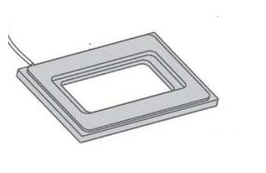
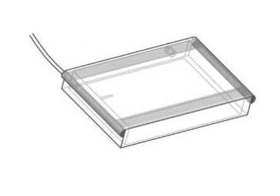
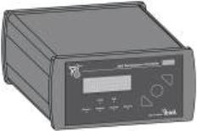
Nomenclature
TEMPERATURE
CONTROLLER
HEATED LID
HEATED PLATE
WARNING! Only operate the ibidi heating devices with an ibidi Temperature Controller.
WARNING! Only operate the ibidi heating devices with the supplied cables and plugs. Using
other cables, etc. poses a risk of electrical shock and fire.
WARNING! Do not operate the ibidi heating devices with substances, or under conditions,
that can cause a risk of explosion, implosion or the release of gases. Only operate the ibidi
heating devices with aqueous solutions.
CAUTION Ensure that the power plug is well accessible. The ibidi heating devices must be
installed in a way that they do not hinder the access to the power plug.
CAUTION Some accessible parts of the plate and lid can reach temperatures up to 55°C.
Avoid touching the temperature-controlled parts of the system when you have set the
temperature controller to high temperatures.
CAUTION If the glass plate of the heated lid breaks due to a mechanical impact, the shards
can lead to injuries if handled.
CAUTION Be aware that when the system is switched on, 10 V AC voltage is applied to the
underside of the glass plate. Do not touch the underside or put it in contact with anything
conductive. This could cause a short circuit that may destroy the temperature controller
and/or the lid.
CAUTION Only use the heating devices in dry rooms, and do not use the heating devices in
the cold room.
CAUTION Use the devices only for cell experiments with aqueous solutions.
CAUTION Do not use the heating devices with hazardous substances or
substances/materials that pose a risk of infections.
Heated Lid & Heated Plate for 1 Chamber (Universal Fit), Instruction Manual
©ibidi GmbH 2014, version 1.2, 2014-08-27
5


Specifications
Supply Voltage
Heated Lid
Heated Plate

10 V / 50 Hz - 10 V / 60 Hz
12 V / 50 Hz – 12 V / 60 Hz
Surrounding Conditions
Storage Temperature
Operating Temperature
Humidity

-5 – 50°C
15 - 40°C (Indoor use only)
80 % relative humidity up to 31°C,
30 % relative humidity up to 40°C
Operating Altitude
max. 2000 m
Temperature Control Range
Ambient temperature to +55°C
Net Dimensions (hxwxd)
Heated Plate with Lid
25.5 x 125.5 x 85.5 mm³
210 g
Weight
Heated Plate with Lid
Recommended Temperatures
before Calibration
(see 3.1 Calibration Routine)
Heated Lid
Heated Plate (Channel 2)
(Channel 1)
42°C
37°C
Heated Lid & Heated Plate for 1 Chamber (Universal Fit), Instruction Manual
©ibidi GmbH 2014, version 1.2, 2014-08-27
6

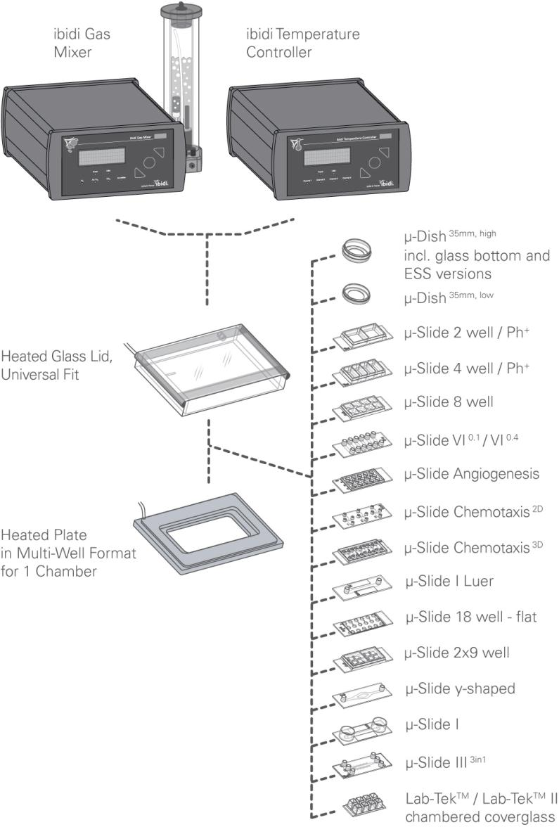
Compatibility
Heated Lid & Heated Plate for 1 Chamber (Universal Fit), Instruction Manual
©ibidi GmbH 2014, version 1.2, 2014-08-27
7

Preface
This manual is your guide to using the ibidi Heated Lid & Heated Plate for cell culture
experiments on an optical microscope. It instructs first-time users how to use the
instrument, and serves as a reference for experienced users.
Before using the ibidi heating devices, please read this instruction manual carefully, and
make sure that the contents are fully understood. This manual should be easily accessible to
the operator at all times during instrument operation. When not using the devices, keep this
manual in a safe place. If this manual gets lost, order a replacement from ibidi GmbH.
Notices
1. ibidi shall not be held liable, either directly or indirectly, for any consequential damage
incurred as a result of product use.
2. Prohibitions on the use of ibidi software
• Copying software other than for backup
• Transfer or licensing of the right to use software to a third party
• Disclosure of confidential information regarding software
• Modification of software
• Use of software on multiple workstations, network terminals, or by other
methods
3. The contents of this manual are subject to change without notice for product
improvement.
4. This manual is considered complete and accurate at the time of publication.
5. This manual does not guarantee the validity of any patent rights or other rights.
6. If an ibidi software program has failed causing an error or improper operation, it may
be due to a conflict from another program operating on the notebook (PC). In this
case, take corrective action by uninstalling the conflicting product(s).
7. ibidi is a registered trademark of ibidi GmbH in Germany and other countries.
Heated Lid & Heated Plate for 1 Chamber (Universal Fit), Instruction Manual
8
©ibidi GmbH 2014, version 1.2, 2014-08-27

Limited Warranty
Products sold by ibidi, unless otherwise specified, are under warranty for a period of one
year from the date of shipment, and should be delivered free of defects in materials and
workmanship. If any defects in the product are found during this warranty period, ibidi will
repair or replace the defective part(s) or product free of charge.
THIS WARRANTY DOES NOT APPLY TO DEFECTS RESULTING FROM THE FOLLOWING:
1
2
IMPROPER OR INADEQUATE INSTALLATION.
IMPROPER OR INADEQUATE OPERATION, MAINTENANCE, ADJUSTMENT, OR
CALIBRATION.
3
4
5
UNAUTHORIZED MODIFICATION OR MISUSE.
USE OF UNAUTHORIZED CELL CULTURE WARE.
USE OF CONSUMABLES, DISPOSABLES, AND PARTS NOT SUPPLIED BY AN
AUTHORIZED IBIDI DISTRIBUTOR.
6
7
CORROSION DUE TO THE USE OF IMPROPER SOLVENTS, SAMPLES, OR DUE TO
SURROUNDING GASES.
ACCIDENTS BEYOND IBIDI’S CONTROL, INCLUDING NATURAL DISASTERS.
This warranty does not cover consumables like cell culture dishes, reagents, and the like.
The warranty for all parts supplied and repairs provided under this warranty expires on the
warranty expiration date of the original product. For inquiries concerning repair service,
contact ibidi after confirming the model name and serial number of your ibidi system.
Heated Lid & Heated Plate for 1 Chamber (Universal Fit), Instruction Manual
©ibidi GmbH 2014, version 1.2, 2014-08-27
9

Installation Requirements
To ensure operation safety, observe the following conditions:
1. Only operate the ibidi heating devices with an ibidi Temperature Controller and with
the supplied power cable.
2. Ensure that the power plug of the power supply is well accessible. The ibidi heating
devices must be installed in a way that they do not hinder the access to the external
power supply and its power plug.
3. Only operate the ibidi Heated Plate with original ibidi inserts.
4. Operate the heating devices in a temperature range of 15 – 40°C.
5. Operate the heating devices in a humidity range of 0 – 80% RH up to 31°C and 30%
RH up to 40 °C.
6. Operate the heating devices in an atmospheric pressure range of 800 – 1060 hPa.
7. Do not operate the heating devices under conditions that pose a risk of explosion,
implosion, or the risk of any gas release.
8. Avoid strong magnetic fields and sources of high frequency. The heating devices
may not function properly when operating near a strong magnetic field or high
frequency source.
9. Avoid vibrations from vacuum pumps, centrifuges, electric motors, processing
equipment and machine tools.
10. Avoid dust and corrosive gas. Do not install the heating devices where they may be
exposed to dust, especially in locations exposed to outside air or ventilation outlets.
11. Do not install the heating devices in a location where they may be exposed to direct
sunlight.
12. Install the heating devices in a horizontal and stable position. This includes a table,
bench, or desk upon which the devices are installed.
13. Ensure that no air conditioner blows air directly onto the heating devices. This may
prevent stable conditions.
14. Install the heating devices in a location that allows easy access for maintenance.
NOTE: The above conditions do not guarantee optimal performance of these heating
devices.
Heated Lid & Heated Plate for 1 Chamber (Universal Fit), Instruction Manual
10
©ibidi GmbH 2014, version 1.2, 2014-08-27

Installation and Connecting Cables
Connecting the ibidi heating devices to the ibidi Temperature Controller
Confirm that the power switch of the temperature controller is off (power switch is at the
right, rear side of the temperature controller).
Connect the heated lid and the heated plate to the connectors at the rear of the
Temperature Controller. Connect each device to the connector labeled with the number of
the channel you want to use. (e.g. Channel “1” for the heated lid, Channel “2” for the
heated plate).
WARNING! Only operate the ibidi heating system with the supplied cables and plugs,
because not doing so may put you at risk of electrical shock and fire.
CAUTION Ensure that the power plug of the external power supply is well accessible. The
heating system must be installed in a way that it does not hinder the access to its power
plug.
Connect the temperature controller to a Notebook by using the supplied network cable.
(Only necessary when using a PC to control the Heating System.)
Switch on the temperature controller and the Notebook.
Heated Lid & Heated Plate for 1 Chamber (Universal Fit), Instruction Manual
©ibidi GmbH 2014, version 1.2, 2014-08-27
11

Maintenance and Operation
Pay close attention to the heating devices operating environment and always keep it clean
so that the heating devices can be used in a stabilized condition over a long period of time.
Operating the ibidi Heating Devices
Use the devices only in the intended application described in this manual.
CAUTION Unintended use which is not in compliance with this manual, can lead to a failure
of the devices’ protective systems. This failure may cause personal injury or damage.
Cleaning the ibidi Heating Devices
Switch off the temperature controller and disconnect the heating devices from the
controller. To clean the devices, use only a dry cloth or a cloth dampened with water
(ultrapure) or common lab disinfection solutions that are based on quaternary ammonium
compounds (e.g., Barrycidal 36 or Pharmacidal).
CAUTION The use of ethanol or other types of organic solvents to clean the devices may
remove the devices’ paint.
Transporting the ibidi Heating Devices
First, switch off the temperature controller and then disconnect the heating devices from the
controller. Carry the devices carefully and avoid mechanical shocks.
Repairing the ibidi Heating Devices
Do not try to repair the devices by yourself. Contact the ibidi service to repair any damaged
components.
CAUTION The manual disassembling of the devices is not allowed. Manual disassembling
poses a risk of personal injury or damage to the devices. Contact ibidi service personnel if
there is need to disassemble the devices.
Heated Lid & Heated Plate for 1 Chamber (Universal Fit), Instruction Manual
12
©ibidi GmbH 2014, version 1.2, 2014-08-27

Waste Treatment
Waste treatment is your own responsibility. You must dispose of the waste using a
company that specializes in waste recovery. Do not dispose of the ibidi heating devices in a
trash bin or at a public waste disposable site. For detailed information, please contact the
ibidi service.
Heated Lid & Heated Plate for 1 Chamber (Universal Fit), Instruction Manual
©ibidi GmbH 2014, version 1.2, 2014-08-27
13

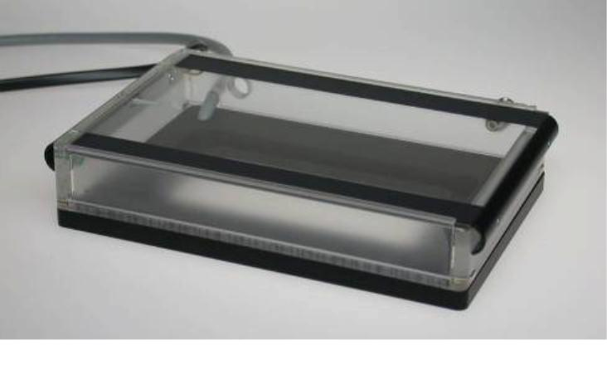
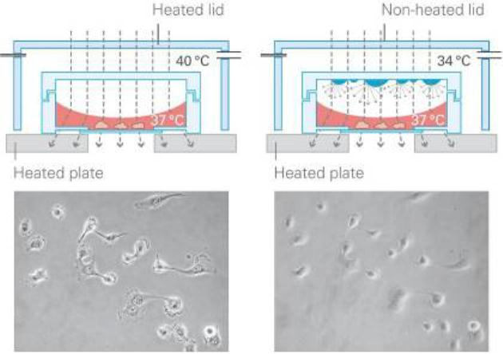
1 Working Principle
The heated plate and the heated lid are designed to keep cells at 37°C in microscopy slides
and dishes. The heated lid prevents condensation effects inside the entire incubation
system. Humidity, CO2-enriched, and/or O2-reduced/enriched air can be flushed in, which
makes the heated chamber a fully controlled incubator — right on the microscope. This
system enables the user to perform live cell imaging.
The glass top of the lid and the bottom plate are actively heat-controlled. The heated plate
has the outer dimensions of a 96-well plate (127.5 mm x 85.5 mm).
Figure 1: Schematic Drawing of the ibidi Heating Devices
Figure 2: Heated Lid and Heated Plate (without Insert)
Heated Lid & Heated Plate for 1 Chamber (Universal Fit), Instruction Manual
14
©ibidi GmbH 2014, version 1.2, 2014-08-27

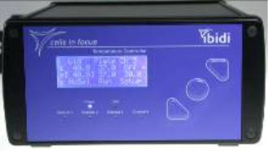


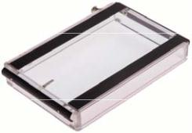
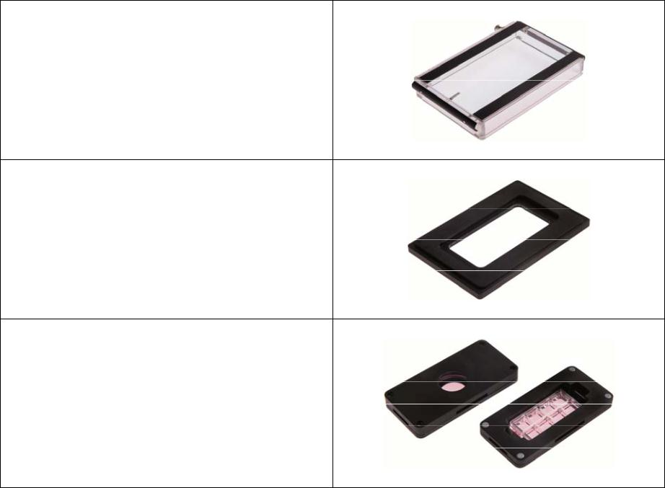
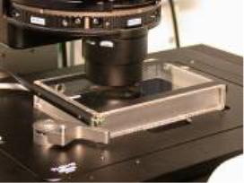

2 Overview
2.1 Product Description
A brief overview is provided in this section, including the nomenclature for later descriptions
in this document.
Heating
Devices
Temperature
Controller
Optional: PC
Figure 3: Schematic Setup
2.2 Components
ibidi Heated Glass Lid, Universal Fit
ibidi Heated Plate in Multi-Well Format,
for 1 Chamber
Heating Inserts
Heated Lid & Heated Plate for 1 Chamber (Universal Fit), Instruction Manual
©ibidi GmbH 2014, version 1.2, 2014-08-27
15

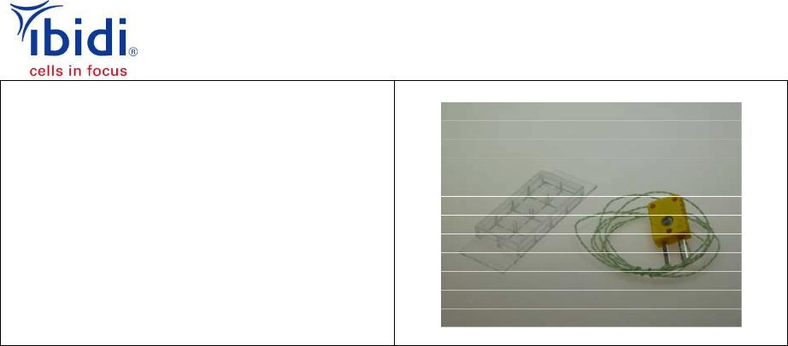
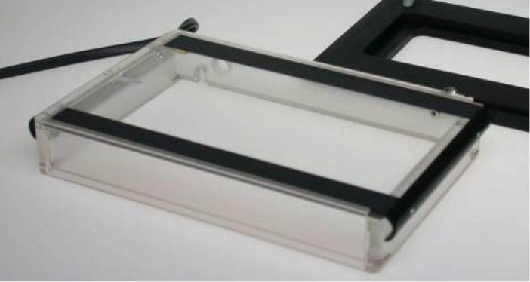


Calibration Set
(1 temperature sensor + 1 perforated μ-Slide
8well for μ-Slide insert)
(1 temperature sensor + 1 perforated μ-Dish
for μ-Dish insert)
2.3 Heated Lid
The heated lid (127.5 mm x 85.5 mm) provides excellent optical quality, and also allows for
the use of all standard microscopy techniques, including differential interference contrast
(DIC). The upper glass part is electrically heat controlled. The heated lid fits exactly and
securely onto the heated plate.
Figure 4: Heated Lid
For gas incubation, the lid is equipped with inlets for (a) the gas flow and (b) the humidity
sensor.
Due to the height of the lid, we recommend using condensers with a working distance of
≥ 26 mm.
Heated plate, heated lid, and inserts are positioned by strong Neodym
Magnets! Please contact us for a non-magnetic system, in the case
that permanent magnetic fields will disturb your experiment!
Heated Lid & Heated Plate for 1 Chamber (Universal Fit), Instruction Manual
16
©ibidi GmbH 2014, version 1.2, 2014-08-27

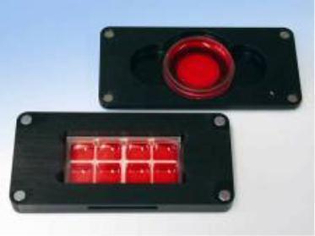
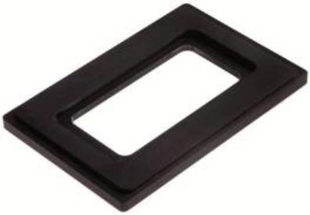

2.4 Heated Plate and Inserts
The heated plate provides the base for the heating system. Its format (127.5 mm x 85.5
mm) fits every multi-well stage or multi-well holder (e.g., for 96-well plates), directly on the
microscope. It is actively heat-controlled. The heated plate is the counterpart to the heated
lid.
The two-part insert has two functions that both use the force of the integrated magnets. The
first function is to hold the μ-Slides or μ-Dishes firmly into position, so as to avoid
displacement during microscope stage movements. The second is to create a tight contact
of the μ-Slides or μ-Dishes to the metallic insert, which then maximizes the heat transfer and
ensures the stable heat control of the sample. The heated plate passively heats the inserts.
Figure 5: Heated Plate with Inserts
To make sure that μ-Dishes are properly placed, a diagonal force must be applied by the lid
of the insert in order to snap the dishes into a fixed position. The lid of the insert will leave a
crooked gap, as shown in Figure 6, but this is normal.
Figure 6: Schematic Drawing of the Insert forμ-Dishes
Heated plate, heated lid, and inserts are positioned by strong Neodym
Magnets! Please contact us for a non-magnetic system, in the case
that permanent magnetic fields will disturb your experiment!
Heated Lid & Heated Plate for 1 Chamber (Universal Fit), Instruction Manual
©ibidi GmbH 2014, version 1.2, 2014-08-27
17






2.5 Sterilization and Cleaning
The Heated Plate and the Heated Lid do not have to be sterile, because the incubation
chamber has no direct contact with the cells and the cell media. If sterilization is necessary
for some reason, we recommend using isopropanol (70%) or common lab disinfection
solutions based on quaternary ammonium compounds (e.g. Barrycidal 36 or Pharmacidal).
All Heating Devices can be cleaned. We recommend using ultrapure water for cleaning.
Stains on the Heated Lid can be removed using isopropanol (70%) or lens/eyeglass cleaning
wipes.
2.6 Setting into Operation
Here is the procedure for starting the operation of the heating devices in combination with
the ibidi Temperature Controller.
For the first power up, we recommend disconnecting the heating devices (e.g., the heated
lid and the heated plate). By doing this, you ensure that you do not start heating with the
wrong temperature settings. It is now possible to set the temperatures for the individual
channels. Afterwards, you can reconnect the heating devices.
Since the controller is preconfigured, we recommend connecting the heated lid to Channel 1
and the heated plate to Channel 2. For subsequent power ups, you will not need to
disconnect the heating devices.
Please let the temperature of the system equilibrate for a
minimum of 30 minutes before you start your experiments.
Be aware that when the system is switched on, 10V AC
voltage is applied to the underside of the glass plate. Do not
touch the underside or contact it with anything conductive.
This could cause a short circuit that may destroy the
controller and/or the lid.
Heated Lid & Heated Plate for 1 Chamber (Universal Fit), Instruction Manual
18
©ibidi GmbH 2014, version 1.2, 2014-08-27



3 Temperature Calibration
The temperature at the position of the cells must be calibrated from time to time, due to the
following conditions: room temperature, air conditioning, heat loss via microscope, chamber
type or objective lens, and humidification. A calibration is recommended before beginning
the first experiment. The heat calibration should be done for each chamber type, in order to
control temperatures with an absolute accuracy of less than 1 °C.
For calibration, the ibidi Temperature Controller has a plug, located on the rear panel, for an
external temperature sensor. Before shipment, all controllers are run through an in-house
calibration to ensure their accuracy. This calibration only refers to the actively heated
devices, such as the plate and the lid. In most cases, the cell temperature will lie somewhat
below the temperature of the heated plate. To compensate for this effect, the heated plate
can be calibrated to the cell temperature that is sensed by the external temperature sensor,
which can be placed at the position of the cells.
The displayed temperatures are valid for the heating
devices only. The temperature near the cells might
be different (lower in most cases)!
3.1 Calibration Routine
The recommended calibration routine is fairly simple. Follow these eight steps for the initial
temperature calibration:
1) Plug the external temperature (e.g., thermo-couple type K) sensor into the rear panel
of the temperature controller. Select the correct input for the display of the sensor
(TC-K, see Instruction Manual Temperature Controller, Section A.2).
2) Fill the μ-Slide or μ-Dish with medium, then place the sensor as close as possible to
the future position of the cells. Use the prepared calibration set, which consists of a
μ-Dish or a μ-Slide with a perforated lid, as shown in Figure 7.
3) Set all parameters to create conditions identical to those of the actual experiments,
such as room temperature, air conditioning, airflow, illumination, microscope settings,
etc.
4) Set the temperature of the heated plate to the desired cell temperature and set the
temperature of the lid several degrees higher (recommended values: plate 37 °C, lid
42 °C). You can do this directly with the control buttons on the controller, or with the
TempControl software.
5) Let the system equilibrate for 30 minutes.
Heated Lid & Heated Plate for 1 Chamber (Universal Fit), Instruction Manual
©ibidi GmbH 2014, version 1.2, 2014-08-27
19



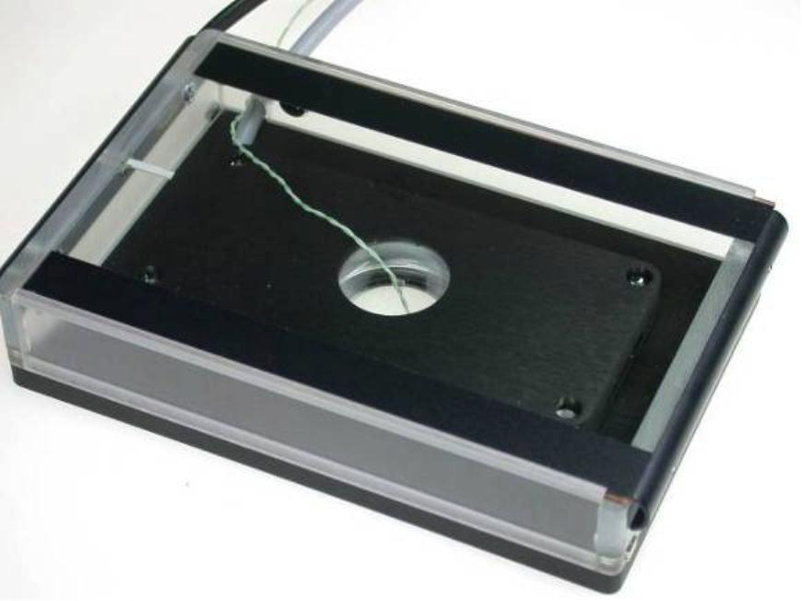
6) In most cases the temperature shown by the external sensor will not match the value
of the plate. In this case increase or decrease the temperature of the plate
(recommended in 0.5 °C steps for small deviations). Let the system equilibrate for
another 5 minutes.
Repeat this step until you reach the desired temperature at the external sensor.
7) Note the adjusted set values in your documentation for future experiments.
8) Check the temperature of the system from time to time.
It is recommended to perform this routine for both
insert types, and once every year.
It is recommended to perform this routine when a
change of temperature conditions has occurred.
Figure 7: Sensor Placement for Temperature Calibration
Heated Lid & Heated Plate for 1 Chamber (Universal Fit), Instruction Manual
20
©ibidi GmbH 2014, version 1.2, 2014-08-27

3.2 Influence of Surrounding Temperature and Airflow
The surrounding, ambient temperature affects the temperature inside the microscopy
chambers. Devices, such as computers and camera controllers, can significantly heat up
small rooms. In this case, we recommend equilibrating the room temperature to the typical
experimental conditions at least 2-3 hours before calibrating.
Keep in mind that the temperature sensor can also measure room temperatures.
The airflow can enhance the effect of temperature changes in the vicinity of the incubation
chamber. In a case where the airflow (e.g., air conditioning, etc.) cannot be stopped, we
recommend protecting the microscope as much as possible from any strong airflow. Please
contact us for support.
Heated Lid & Heated Plate for 1 Chamber (Universal Fit), Instruction Manual
©ibidi GmbH 2014, version 1.2, 2014-08-27
21

4 Troubleshooting
4.1 Focus Not Stable
Focus drift is a disturbing effect, especially during time-lapse experiments. Focus stability is
mainly influenced by mechanical changes and temperature variations. Follow these
recommendations to keep your cells in focus:
•
•
•
•
•
Switch on all components (e.g., heating, gas incubation, computer, or other
equipment) at least 60 minutes before starting the experiment.
After you put the sample onto the microscope, wait 20 minutes before starting a
time-lapse experiment to achieve temperature and immersion oil equilibration. (*)
Keep the room temperature as stable as possible. Air conditioning should either be
working continuously or switched off.
Do not change the temperature during the experiments. Avoid door/window
openings, as this could rapidly change the temperature.
Eliminate all sources of mechanical vibrations. Use a damped table for your
microscope.
(*) In case the experiment needs to be started immediately, either after placing the sample
on the microscope or after closing the lid, we recommend controlling the focus for 20
minutes. In the first minutes after starting the experiment, temperature equilibration might
influence the focus/z-position of the cells.
4.2 Evaporation Too High
Depending on the incubating conditions, small volumes might evaporate quickly, especially
during long-term experiments. We suggest using silicone oil (e.g. Anti-Evaporation Oil, ibidi,
50051) to decrease evaporation. If you have an actively controlled humidifying device,
increase the set value of relative humidity.
4.2.1
Silicone Oil Procedure (ibidi’s Anti-Evaporation Oil)
Covering the medium with sterile silicone oil prevents all evaporation effects and is
compatible with cell culture. Please don’t use mineral oil, as this would be harmful to the
ibidi μ-Slides.
Equilibrate oil and medium inside the incubator overnight. This step helps avoid the
formation of air bubbles, and pre-warms the solutions to 37°C. Afterwards, fill your slide
with cells and medium. Cover the medium’s surface with an appropriate amount of silicone
oil. Don’t drip the oil directly onto the surface, but let it run down the edges by pressing the
pipette tip directly on the upper side of the reservoir. For example, when using the ibidi μ-
Slide VI
0.4
, fill each reservoir with 30 μl cell-free medium and 30 μl of silicone oil.
Please contact us at info@ibidi.com for further troubleshooting help.
Heated Lid & Heated Plate for 1 Chamber (Universal Fit), Instruction Manual
22
©ibidi GmbH 2014, version 1.2, 2014-08-27


5 WEEE/RoHS Compliance Statement
EU Directives WEEE and RoHS
To Our Valued Customers:
ibidi GmbH is committed to being a good corporate citizen. As part of that commitment, we
strive to maintain an environmentally conscious manufacturing operation. The European
Union (EU) has enacted two directives, the first on product recycling (Waste Electrical and
Electronic Equipment, WEEE) and the second on limiting the use of certain substances
(Restriction on the use of Hazardous Substances, RoHS).
Two Categories of products covered by the WEEE Directive are currently exempt from the
RoHS Directive – Category 8, medical devices (with the exception of implanted or infected
products) and Category 9, monitoring and control instruments.
All of our products fall into either Category 8 or 9, and are currently exempt from the RoHS
Directive. We will, however, continue to monitor the application of the RoHS Directive in
relation to our products and will comply with any changes, as they apply.
Recycling is offered for our products that fall within the scope of the WEEE Directive. These
specific products, available for sale after August 13, 2005, will be identified with a “wheelie
bin” symbol.
When you see this symbol, do not dispose of this product with Municipal Waste. Special
Collection/Disposal is required.
Please contact us for feedback or further information.
ibidi GmbH
Am Klopferspitz 19
82152 Planegg-Martinsried
Germany
www.ibidi.com
info@ibidi.de
Tel.: +49 89 520 4617 0
Fax: +49 89 520 4617 59
Heated Lid & Heated Plate for 1 Chamber (Universal Fit), Instruction Manual
©ibidi GmbH 2014, version 1.2, 2014-08-27
23

